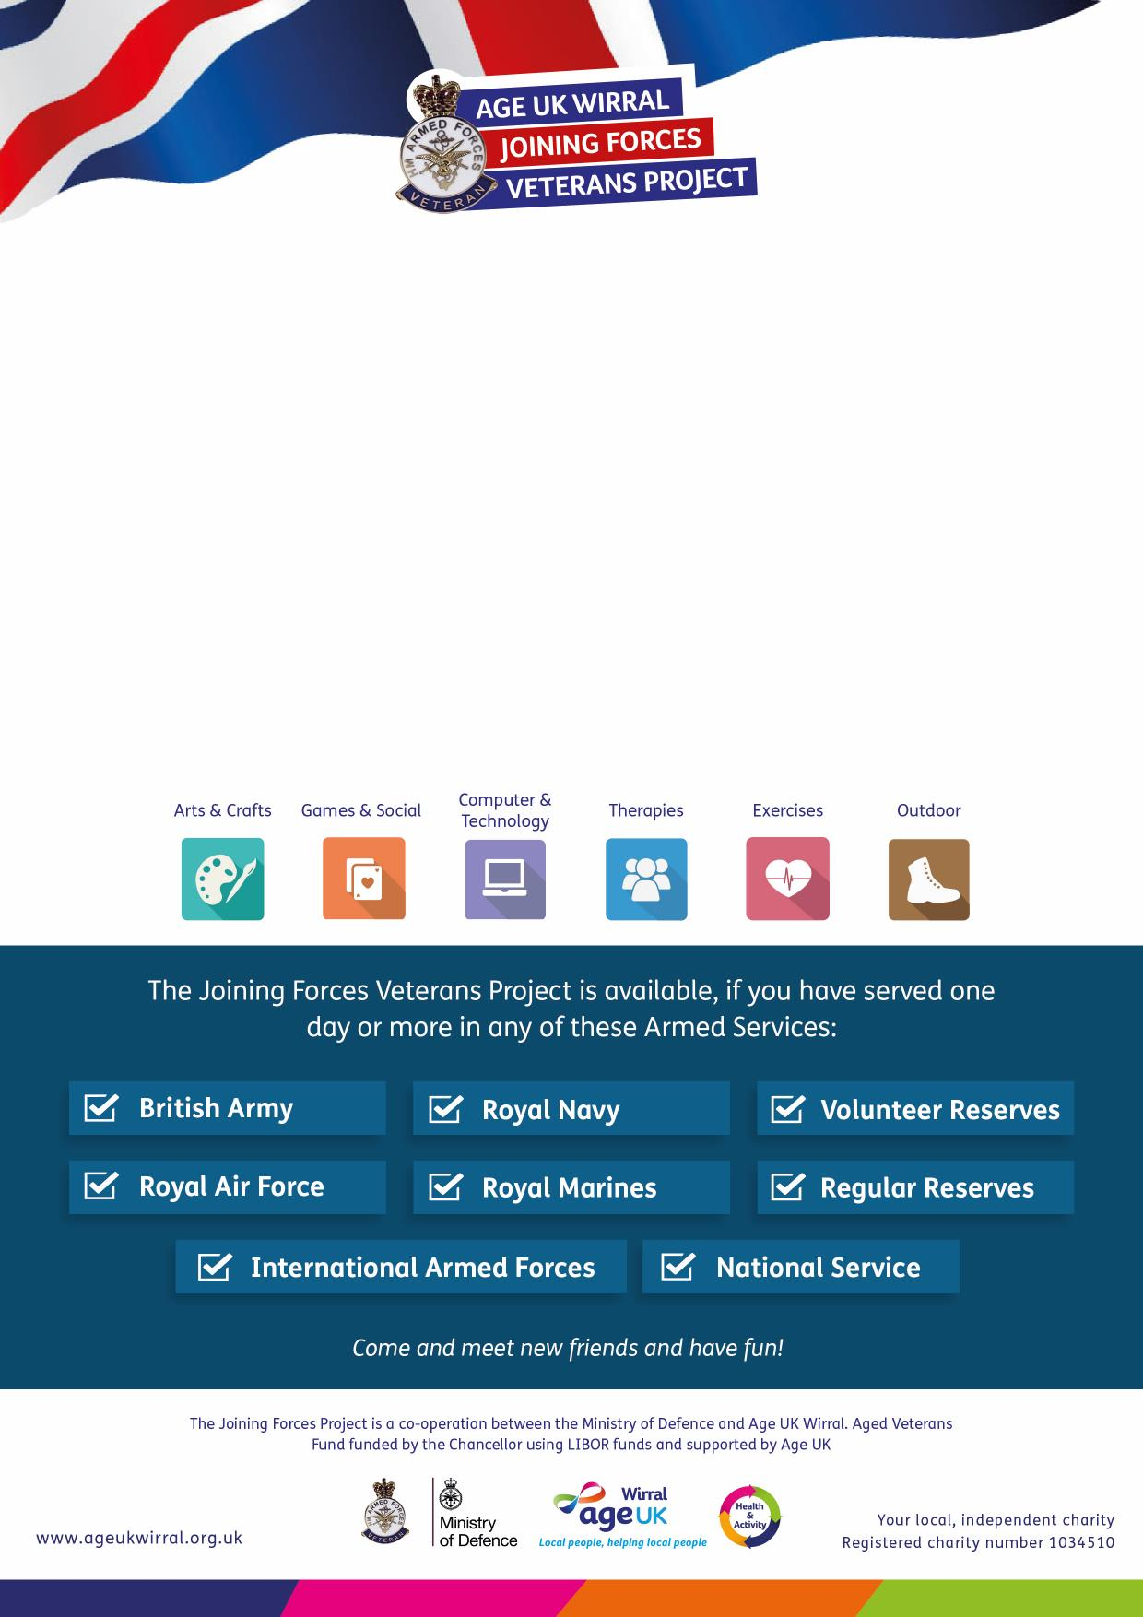

**Veteran’s Coffee Morning**   
Join us for a cuppa and bacon butty* in our Community Drop-in Lounge

at **Meadowcroft Activity Hub, 304 Spital Road,**

**Bromborough CH62 2DE**

on the first **Monday** of each month

**10am – 12pm**

Sit and relax whilst having a cup of tea or coffee and find out about the

services and activities offered by the Joining Forces Veterans Project

*Please note bacon butties are £2.50

**For more information please call:  
0151 482 3456**

The **Joining Forces Veterans Project** provides you with a range of activities and   
services designed to meet your needs, right here in Wirral.

***For more information please call:  
0151 482 3456***

The **Joining Forces Veterans Project** provides you with a range of activities and   
services designed to meet your needs, right here in Wirral.