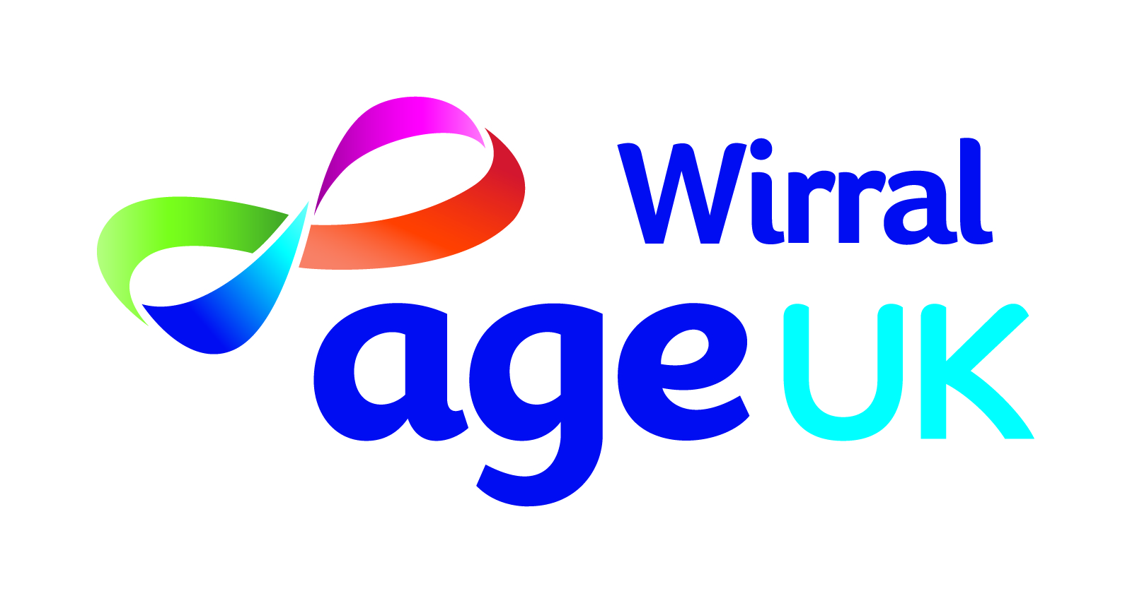
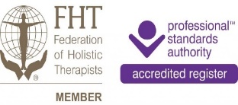
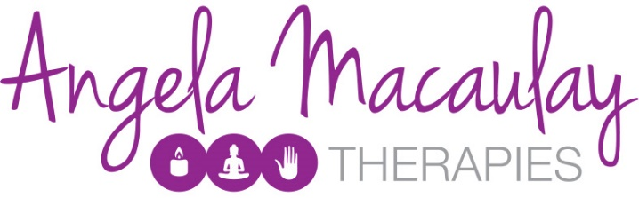

Meadowcroft, 304 Spital Road, Bromborough, CH62 2DE
Relaxing treatments for mental health and emotional wellbeing
£20.00 per 1 hour treatment
Mondays
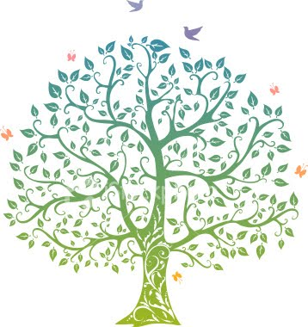
By appointment on 0151 482 3456

Indian Head Massage
A safe, gentle and effective massage that focuses on the head, face, neck and shoulders. This treatment assists people who suffer from headaches, stress and anxiety. The client is seated for this treatment and may remain clothed.
Facial massage – Tsuboki Japanese facial
This is a wonderfully relaxing yet energising treatment. A relaxing and restorative health-giving treatment. The client remains fully clothed. Treatment may be given lying down or seated.
Back Massage or Full body Swedish Massage
This massage is overall very relaxing and helps rid the body of tension. Various strokes are performed directly on the body, using oil to aid the process.
The client’s body is covered with towels. Treatment is given lying down.
Reiki
Reiki is a Japanese technique for stress reduction. A non-intrusive, truly relaxing and uplifting experience that revitalizes and rebalances energy flow to the body, giving a deeply calming effect. Client remains fully clothed. Treatment may be given seated or lying down.

