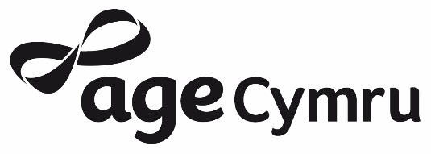

Winter Celebration Grant Eligibility and Criteria

Through funding from Age Cymru, one-off grants of up to £200 are available for social events at winter time.

Eligibility
In order to apply for this grant programme applicants must be a local older people’s group in Wales.
- An older people’s group is understood to be an organised group of older people meeting regularly for social, recreational and other mutually beneficial purposes.
- The group must be properly established, with a clear set of rules, constitution or terms of reference.
- The group must have its own bank account, as the grant will only be paid by BACS.
- Grants cannot be made to individuals.

What type of activity can be funded?
- Christmas lunches or Christmas parties
- New Year celebrations
- Chinese New Year celebrations
- Outings to the theatre or pantomime
- Christmas shopping trips
- Theatre trips
- Other relevant winter celebration, meal or outing

Activities must take place between December 2019 and 29 February 2020.

This grant programme will not fund the following:
- Activities not taking place between December 2019 and 29 February 2020
- Winter warmth services and projects
- Activities that will not directly benefit people in later life
- Grants must be for specific items, and not a contribution to general funds
- Activities organised by national organisations

Conditions:
- The grant must be spent for the purposes detailed in your application and must be accounted for as a restricted fund.
- Successful grant applicants will be expected to provide Age Cymru with a report in March 2020 on the outcomes of the project showing how the grant funding has been used. A report template will be provided.
- Media – although not a condition of the grant we would be delighted if you are able to achieve some press coverage about your Winter Celebration to show that you have received a grant to help older people in your local community and how it was used. We will ask to see any copies of coverage with your final report. Age Cymru will provide press templates.

How do we apply?
- Please complete the application form provided. Please give clear and concise answers to all the questions on the form.
- All completed forms received by the Age Cymru will be acknowledged. On the acknowledgement letter there will be a reference number for future use in any correspondence regarding the project. Please use this number as a point of reference if you have any queries regarding your application and need to contact us.

Filling in the Application Form:
- Please give the official name of the organisation that will be responsible for delivering the project and administering the grant.
- Please provide the name of the person who will have particular responsibility for your Winter Celebration Grant.
- You must enclose a copy of your latest Income and Expenditure Accounts with your application. These should be the accounts showing your Income and Expenditure for the previous year, and approved at your Annual General Meeting – a bank statement is not sufficient. If the accounts are not included, your application will not be considered.

Next steps:
- Successful grant applicants will receive a formal acknowledgement form to sign and return, a report template, a case study template and a BACS payment form to be completed and returned.
- Grants cannot be paid until the acknowledgement form and the BACS payment form have been received.

Please send your completed application form to:

Winter Celebration Grants
Age Cymru
Ground Floor, Mariners House
Trident Court
East Moors Road
Cardiff CF24 5TD

