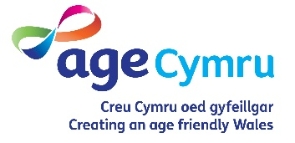
Registration form for friendship call

Name

Telephone number

Email address

Address

Age

Preferred method of communication (Telephone or video chat?)

Emergency contact name and number

Is this a referral on behalf of someone else?

If yes, do you have the permission of the person you are referring.

If yes, your name, contact number and relationship to the person you are referring

For use for registration via telephone
Completed by:
Date:
Once completed send it to: Friends@agecymru.org.uk

We’d like to keep you informed about our vital work. Please tick or circle the areas you’re interested in: Arts [ ] Campaigns [ ] Events [ ] Fundraising [ ] Information and Advice [ ] Policy/Public Affairs [ ] Physical Activity [ ] Volunteering [ ]

Would you like to hear from us, please tick or circle - by post [ ] email [ ] telephone [ ] all [ ]
You can unsubscribe at any time. Call 029 2043 1555 email unsubscribe@agecymru.org.uk or tick / circle this box [ ]

Your details will be kept on a secure database and we will not share your details with any organisations unless required by law.

Hoffem eich diweddaru am ein gwaith hanfodol. Ticiwch neu rhowch gylch yn y meysydd sydd o ddiddordeb i chi: Celfyddydau [ ] Ymgyrchoedd [ ] Digwyddiadau [ ] Codi Arian [ ] Gwybodaeth a Chyngor [ ] Polisi/Materion Cyhoeddus [ ] Ymarfer Corff [ ] Gwirfoddoli [ ]
A hoffech i ni gysylltu â chi, ticiwch neu rhowch gylch – drwy’r post [ ] e-bost [ ] ffôn [ ] pob un [ ]
Gallwch ddad-danysgrifio ar unrhyw adeg. Ffoniwch 029 2043 1555 e-bostiwch unsubscribe@agecymru.org.uk neu ticiwch / cylchwch y blwch hwn [ ]
Cedwir eich manylion ar gronfa ddata ddiogel ac ni fyddwn yn rhannu’ch manylion ag unrhyw sefydliad arall oni bai y bydd angen cyfreithiol i wneud hynny.

