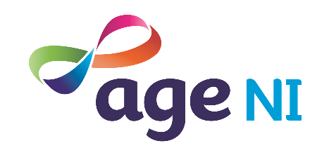
Useful contact numbers

Regional Emergency Social Work Service 028 9504 9999
This number covers all of Northern Ireland.
5pm – 9am Monday to Friday.
Weekends 24 hour service.
Public and Bank holidays 24 hour service.

Age UK helpline 0800 678 1602

British Red Cross 028 9073 5350

Covid Community Helpline (Advice NI) 0808 802 0020
Only open 29th and 30th December.

Housing Executive 03448 920 900

Lifeline (crisis) 0808 808 8000

NIE (power cuts) 03457 643 643
NI Water (flooding) 03457 440 088

PSNI (non emergency) 101

Samaritans 116 123
Salvation Army 028 9032 0320
St Vincent de Paul 028 9035 1561

Winter Fuel Payment 0800 731 0160

Visit NI Direct at www.nidirect.gov.uk

