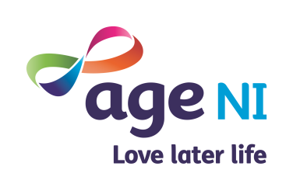 Signpost

### Age Sector News 24th March 2020

### Special Edition for COVID-19

**Welcome to the latest issue of Signpost Express,** a special edition to keep you all updated on specific and relevant issues to the age sector across Northern Ireland during this COVID 19 pandemic. We are all facing a huge impact on our daily lives but one of our messages is to keep connected and be supportive to each other. We may have to change and find new ways of working and I will maintain my support to age sector networks on the phone, via emails or zoom video calls.

The Age Sector Networks across Northern Ireland are engaging with partners, individuals and groups running new emergency programmes during this time of self isolating and social distancing, Local Age Sector Networks may be the first point of contact for some older people so we will do our best to support and share relevant information as widely as possible.

Age NI’s staff roles and priorities have changed over the last week and we will be devising new work plans over the incoming weeks and months. I will use this Signpost Express to include regional and local updates with relevant age sector news and activities, funding updates and key messages.

Age NI are rapidly reviewing our support and want to communicate all new information so keep checking our social media for regular updates. We think that community action will take new forms and we need to offer mutual support to each other. We know that many of you are already promoting and taking key action over the past week so a big thanks to you all for your immediate responses.

**To make this signpost more impactful over the next few months please send us information to highlight corona virus response activities and updated news in your area – to highlight and signpost correctly. If you wish to have anything included in the next Signpost Express, please email me:** [**elaine.curry@ageni.org**](mailto:elaine.curry@ageni.org)

Take care and keep well. Elaine

### News: Regional News

### Regional News

### Coronavirus Update – by Linda Robinson Age NI CEO

### Age NI know many of you will be worried about the COVID-19 outbreak and what it means for you, your family, friends and neighbours and, of course, for older people in our services and in our communities. Age NI are very grateful for the work our staff and volunteers carry out so that older people can stay as well as possible, living the life they wish to live.

### At the moment, and in line with official guidance, Age NI are monitoring the situation closely, responding to the rapidly changing situation and taking steps to safeguard our staff, volunteers and the older people we support. We are putting plans in place so that we can continue to support older people, although how we do this may change over time.

### Over the Easter holiday period in particular, we are calling on everyone to look out for older people we know to make sure they are okay and have the information they need to protect themselves. We are also asking people to think about helping older people by picking up shopping or help with running some errands.

### Please take care of yourself and others. Act on the guidance of PHA at all times. If you feel unwell, have a new continuous cough and/or have a fever, however mild, please follow PHA advice.

### 1. Update on Corona Virus Government Guidelines

### The UK government measures to decrease the number of coronavirus infections as it moves towards its peak, including:

### if someone in your home falls ill, the whole household to isolate itself for 14 days.

### everyone to stop non-essential contact with others and non-essential travel.

### those who can should start working from home, and we should all avoid meeting in social spaces such as pubs, restaurants, cinemas and theatres. These measures are called social distancing.

### People aged over 70, vulnerable i.e. people with underlying health conditions are being asked to stay at home and avoid unnecessary, close contact with other people for up to 12 weeks.

### You’ll still be able to go outside to exercise, or just to get some fresh air, and it’s OK to go to the shops for essentials – provided you don’t have any symptoms. The advice is also to avoid gatherings with friends and family and to use the phone or internet instead. ​

### These measures are tough, but they’re important to shield the most vulnerable from the disease. See the PHA website for updated information: <https://www.publichealth.hscni.net/news/covid-19-coronavirus#situation-in-northern-ireland>

### For more information:

### <https://www.ageuk.org.uk/information-advice/health-wellbeing/conditions-illnesses/coronavirus/>

### <https://www.ageuk.org.uk/northern-ireland/information-advice/coronavirus-covid-19/>

### Check if you have corona virus symptoms:

### <https://111.nhs.uk/covid-19/>

### 

### 2. All staff and volunteers can take part in online training on infection control

### There is a valuable online training course available on infection control. We are asking all staff to click on the links below and complete the training as appropriate to your role. These are open access and can be used by anyone.

### Level 1 for admin roles

### Level 2 for those involved in delivering direct care

### The two links to the programmes are as follows:

### IPC Level 1: https://www.hsclearning.com/course/view.php?id=1029

### IPC Level 2: https://www.hsclearning.com/course/view.php?id=1030

### Please share as you feel appropriate with groups and individuals.

### 3. Guidance for social and community care and residential settings

### The Department of Health is now issuing further guidance for specific types of social, community and residential care provision.

### COVID-19: GUIDANCE FOR NURSING AND RESIDENTIAL CARE HOMES IN NORTHERN IRELAND and COVID-19:

### GUIDANCE FOR DOMICILARY CARE PROVIDERS IN NORTHERN IRELAND.

### Both documents are available on the Department of Health website at <https://www.health-ni.gov.uk/coronavirus> and on the Public Health Agency website at <https://www.publichealth.hscni.net>

### This information will be supplemented with further information and advice in the coming days, as and when it is developed.

### 5. Media coverage – Communications to help

### Decision makers and communicators should consider and think about the language they use. While there are a range of views amongst older people, many are frightened by what they are hearing.

### Keep in touch

### Lend a hand

### Show you care

### Share support and advice numbers

### Donate

### Coronavirus info for the ‘helpers’ – How we can all help: <https://www.ageuk.org.uk/discover/2020/03/ways-to-help-older-people-coronavirus/?utm_source=postcard&utm_medium=offline&utm_campaign=coronavirus>

### 6. Challenges for us all

### We know that we are all facing the same challenges: concern for older people - both those you already know, work alongside and support and those who are now turning to us; how to keep your organisation functioning; and immediate concerns about financial stability.

### We are pressing the Government and others not just to provide great support for older people, other vulnerable groups and the wider public, but also to recognise that they cannot take for granted that charities can keep their doors open. Please understand that we are advocating in every forum we can.

### So what are we doing? Like you, our world has turned upside down. In the last two weeks we have transformed the way that the Age NI Advice Line functions, because we think it is essential to keep it open and are, like you, already seeing a surge in demand. We are working round the clock to put out good quality, up-to-date and reliable information through the media and our website.

### We have nearly completed a move to home working with only key staff coming into the offices and our offices are closed to the public.

### Age NI focuses now is on a new work programme to ensure we are able to step up on all fronts to give older people and our partner the help and support that is needed.

### We are rapidly developing our support to the age sector networks – who are providing key services to local people right now. Community action, action by families, friends and neighbours, new forms of very local mutual self-help and support will be absolutely key.

### 6. Your Support

### Thank you to everyone who has been able to find the time to speak to Age NI colleagues to report on the situation on the ground. We are inspired, but not ultimately surprised by the way in which people across the country is responding to the unprecedented and rapidly changing situation that faces us.

### Thank you for all of the incredible work you have done so far and in advance for all that you and your organisations will go on to do. We thank you all for your dedication and support at this time. Please remember to take care of yourselves and each other.

### Age NI and Age UK News

### Age NI Latest News: Check out <https://www.ageuk.org.uk/northern-ireland/>

### Check out [www.ageni.org](http://www.ageni.org) for details of our latest news, activities, campaigns and ways you can support Age NI during this difficult period.

### Coronavirus info for the public - Key questions and answers: [https://www.ageuk.org.uk/information-advice/health-wellbeing/conditions-illnesses/coronavirus/#](https://www.ageuk.org.uk/information-advice/health-wellbeing/conditions-illnesses/coronavirus/)

### Sign up for Zoom Video Calls – adapt how we communicate with you.

### If you register with Zoom - <https://zoom.us/signup> then we can do our meetings differently – adapting a new method of communicating and engagement with each other. When you register with Zoom - please see a link to a video online on how to join a meeting request:

### <https://support.zoom.us/hc/en-us/articles/201362193-Joining-a-Meeting>

Age Sector Networks

### Age Sector Network Chairs Exchange Meeting

### The last Age Sector Network Chairs Exchange Meeting was held on Tuesday 28th January 2020 – Theme: Planning and Reviewing and sharing a common vision for 2020. Due to the corona virus outbreak we will review who we engage, support and communicate with our Age Sector Networks who provide vital work locally to older people.

### This is a regional emergency and we all need to support the Age Sector Networks to provide ongoing work and share ideas to support our older population. The more effectively we can work together we can reduce the burden on the NHS. This is a huge challenge but we all need to beat this crisis together.

### Age Sector Networks are submitting a funding applications to Community Foundation NI also to assist group leaders to maintain contact with members regarding delivery of meals and groceries. We will keep in touch regarding any further updates.

### Contact details for the Age Sector Networks across N. Ireland are in the link below:

### <https://www.ageuk.org.uk/northern-ireland/get-involved/age-sector/age-sector-networks/>

### Below are some of the support activities via age sector networks and support organisations that can help locally in your Council area – I will keep updating this when networks/ organisations send me information. I am sure each week we will see an increase in support and new programmes.

**MID USTER AREA: Cookstown, Dungannon and Magherafelt**



**STEP Advice and Support Service Covid -19.** For more information contact:

* Dungannon – 02887750211
* Cookstown – 02886761875
* Magherafelt – 02879633079

**Volunteer Offices Closed:** Due to the current situation regarding the Covid-19 outbreak and following Government advice, all Carefully Yours Project activities have been cancelled until further notice. The Volunteer Centre offices in both Magherafelt & Cookstown to the public. This is to reduce face to face contact, however they will remain at work and will be available by telephone on 028 79 301862 or email.  We must do this to protect the health & safety of both our users, as well as our staff and volunteers.

**The HUB Cookstown BT80**

“We are hoping to use The Hub as a base for any of the elderly and vulnerable within our community who need food goods, sanitary products and prescriptions etc lifted/delivered. Please feel free to contact us if we can help you in any other way.

I have a request for anyone who has extra in your cupboards be it toilet roll, sanitary items, sanitizer, anti-bacterial products, tinned or dried foods or anything else you think those who will not be able to get out may need, to drop them to The Hub where we will have staff ready to collect from outside our premises. Drop offs will be daily, starting tomorrow Tuesday 17th March, usually Monday-Friday 9:30am-2pm (contact us directly if you are unable to drop off between these times). Please don't send fresh or short dated foods. There will be volunteers who after packing will distribute throughout the community to those who are in need.

We will also be delivering soup to those who are going to be left housebound, so if you know of anyone, be it yourself or a neighbour please get in contact with us.

**Important Contact Details:** The Hub 02886763398

Out of Hours contact 07761229036 or 07779791195

**O4O Cookstown Ltd** will be closed for sit in dinners and arts and craft sessions with immediate effect until further notice. Their meals on wheels delivery service will continue as normal. If you live within a five miles radius of Cookstown and would like a hot dinner delivered to your door please for them on 028 8676 9005 before 10am. Cost £6.00

**MID & EAST ANTRIM AREA (Ballymena, Carrickfergus, Larne)**

MEAAP will continue to work very closely with Good Morning Services in Larne, Carrickfergus and Ballymena and will be operating a text alert system to all over 50’s with up to date PHA advice and support who people can sign up to this service by calling the helpline number 028 25658604

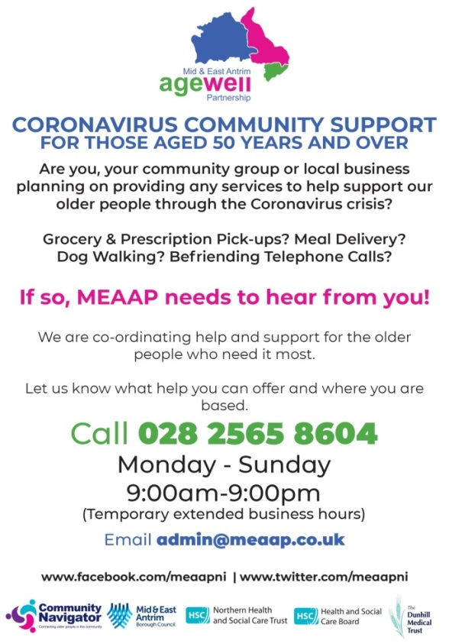

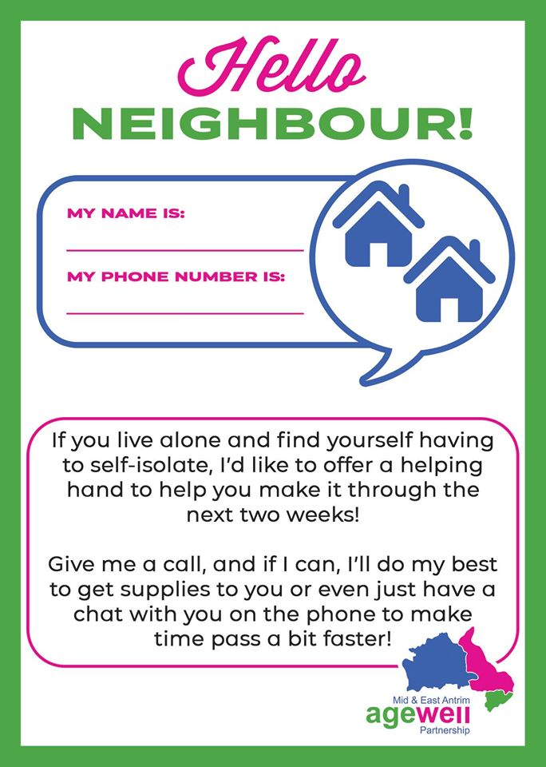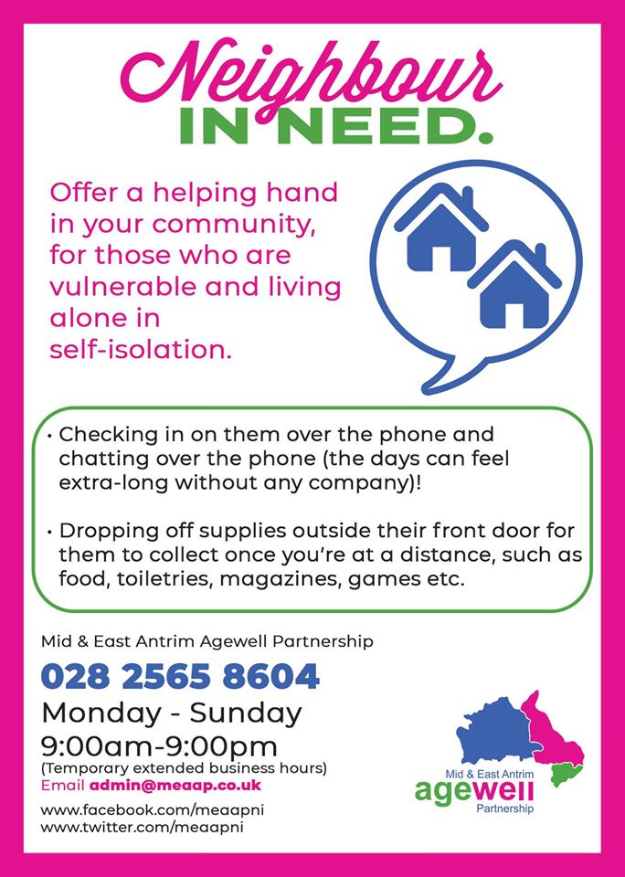

**SWAP (South West Age Partnership) Omagh and Fermanagh areas**

“Due to the ongoing covid 19 situation Allison Forbes will be working from home with limited access to her emails at times. SWAP are acutely aware of the upcoming strain on our older people especially over the next few months.

Please note that local community organisations and partners are coming together to try and co-ordinate a response to the Covid 19 crisis. If you want Allison to share anything on the SWAP Facebook page please let Allison know. “We are all in this together and we are working hard under difficult circumstances to arrange an appropriate response. If any organisations out there want to get involved or have ideas about how to protect our most vulnerable, you can contact me on [aforbes@southwestagepartnership.co.uk](mailto:aforbes@southwestagepartnership.co.uk)”

If you know of an initiative up and running already across Fermanagh and Omagh let Allison know. Stay well, stay safe and stay in touch is their strong message

Please keep in touch with your friends, neighbours and stay well. SWAP’s Facebook page will be updated with credible updates and local knowledge.

<https://www.facebook.com/swapnetwork/>

Samples of local activity by local shops – check out your own local shops online for delivery information.

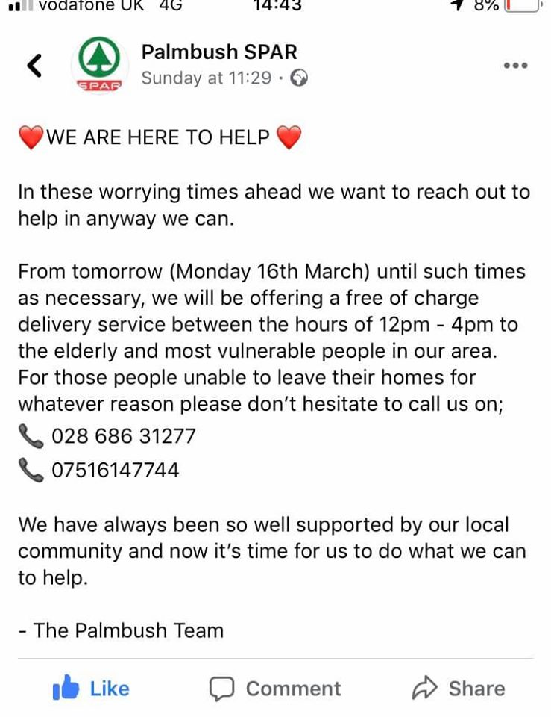 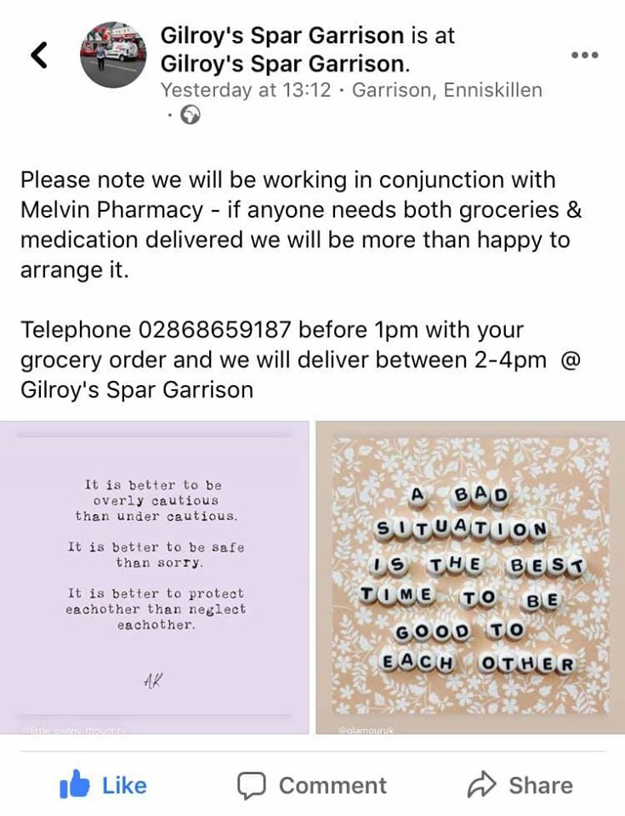

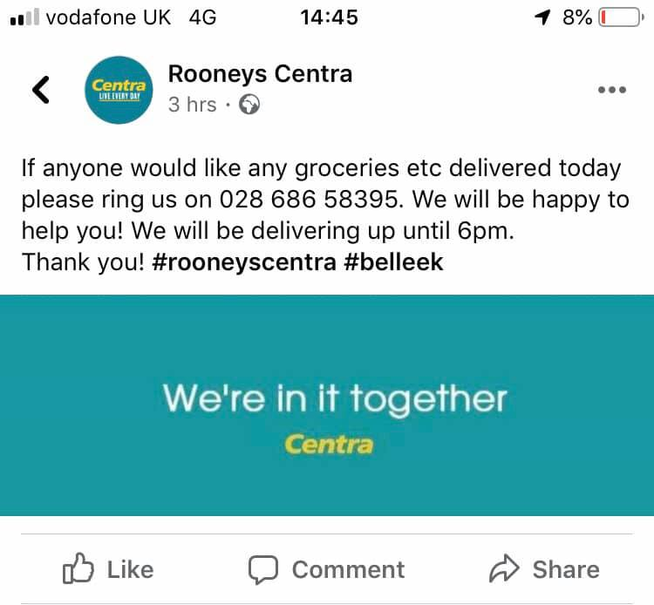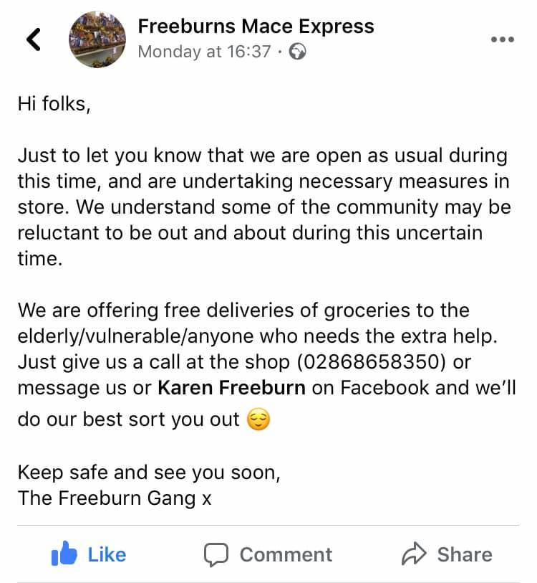

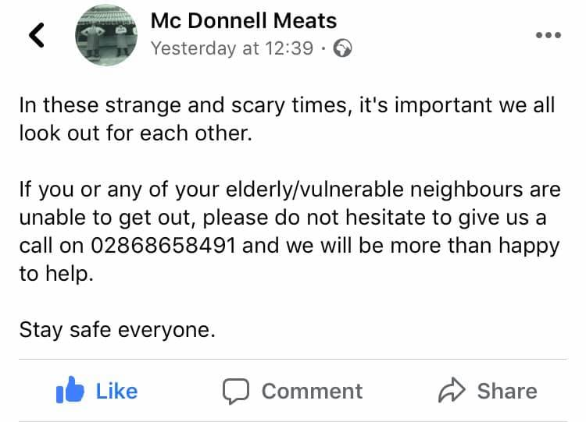

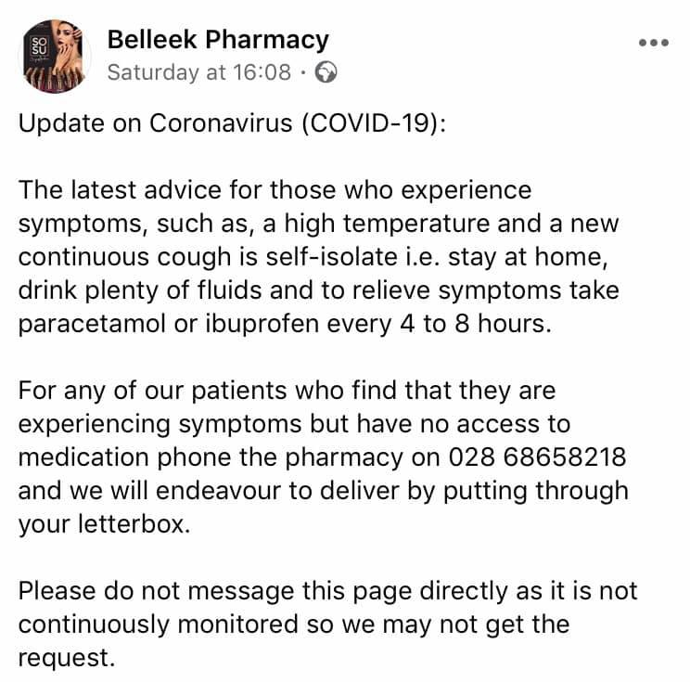 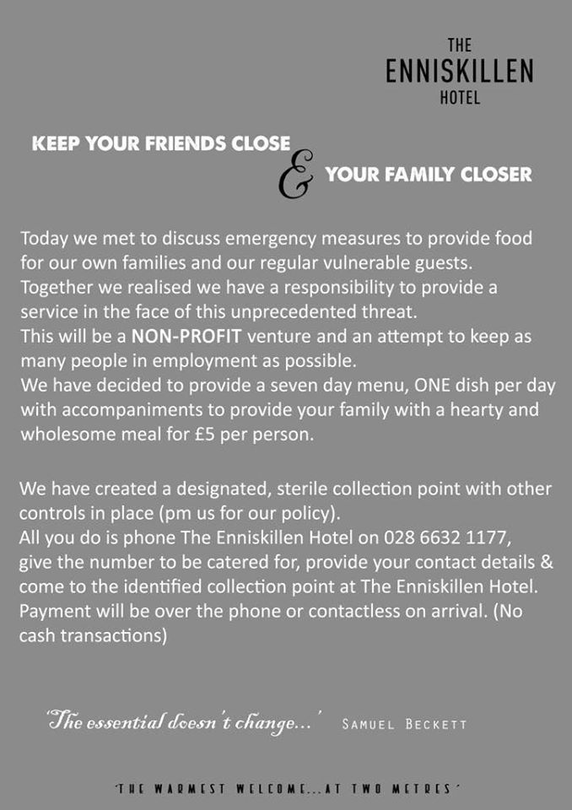

**COAST (Causeway Active and Strategic Team)**

Anyone aged 60+ living in the Causeway Coast and Glens areas and needing extra support at this time can contact COAST on 07517076815.

Our Good Morning Services, Good Morning Causeway, Good Morning Ballycastle and Good Morning Roe Valley are operating as normal and ensuring our older and vulnerable clients are receiving a daily call.

Our Handyperson Service is working on reduced services at present and we are prioritising the fitting of keysafes to allow for hospital discharge, care packages etc. All necessary precautions are being put in place to reduce the risk to our clients.

We will keep up to date with all local initiatives that are helping at this time.

Keep up to date on our Facebook page www.facebook.com/coastnetwork

We can be reached via the mobile number above or email coast.manager@yahoo.co.uk

COAST says “It’s times like these that this charity is made for. We’ve been inundated with calls, messages and queries about how we can help older people in our local community. We are currently engaging with our partners and most importantly, with over 40 of our volunteers to discuss how we can provide the most appropriate and affective assistance at this time.

Plans so far include delivering 50 free Meat Hampers donated by The Copper Pig to older people in the area, as well as a free prescription and necessities delivery service. If you would be interested in helping facilitate this service, by volunteering with the charity, please message the page.

But most importantly, if you, or someone you know is in need of help at this time do not hesitate to get in contact with your local charity for older people.

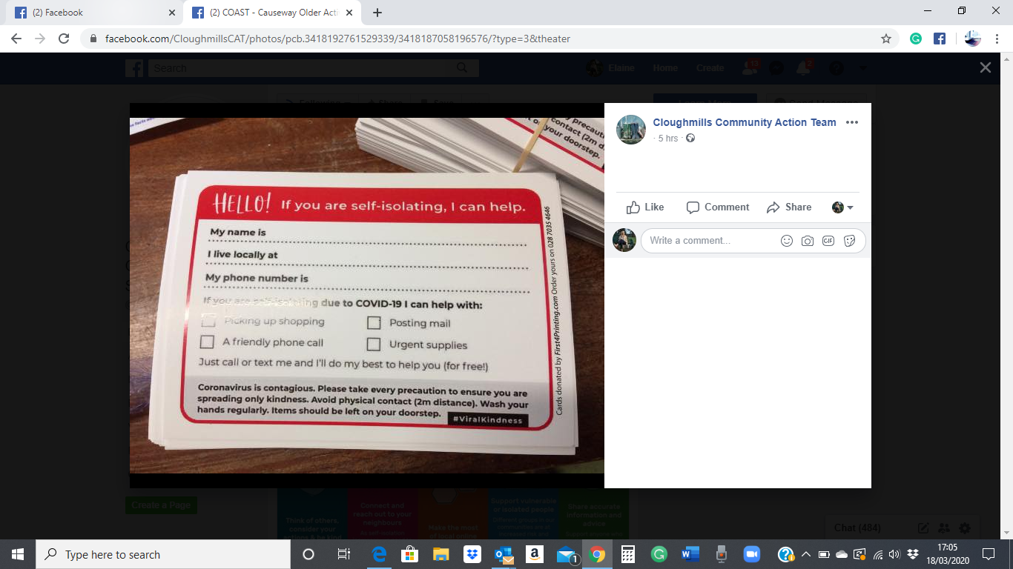Let me take this opportunity to remind you that at this time when we are all unsure of what the future holds, perhaps the most important thing you can do is just to talk to the older people in your community.”

Here is an example of community response: Cloughmills community leaflets going out and shared on COAST Facebook page.

**BCRC Community Navigator for Older People 50+**

If you are concerned about an older person in your community can be accessed via telephone. Please contact Bronagh mobile: 07593 130700

Or by email: communitynavigator@theresourcecentre.org

**SING (Senior Information Network Group) Lisburn, Castlereagh/ Colin**

**New Facebook Page to be developed this week to get information out**

**SIGNPOSTING to Community Support**

Age NI First Connect Officer - George Smith - **07436 581 437**

CASTLEREAGH AREA Isobel Flood- **07592 748 129**

LISBURN & COLIN AREA Geraldine Rice- **07777 1880857**

Good Morning Colin – **028 90627863**

Good Morning Colin is a Telephone Support Service for older and vulnerable people it covers the Colin area , Greater Dunmurry, Urban and rural Lisburn This is a free service which operates 7 days a week 365 days a year anyone wishing to avail of this service please contact myself Isobel Isabel Flood - Coordinator

Good Morning Colin 31 Colin Road Belfast BT17 0LG

Email: [isabel@newcolin.com](mailto:isabel@newcolin.com) Web: www.newcolin.com NI Charity Number: NIC100092

**ADVICE & PRODUCTS**

Age NI Advice Service - Freephone **0808 808 7575**

Free independent and confidential support for older people, their families and carers.

**GROUP SUPPORT**

Capacity Building - Wendy McDowell *(Lisburn & Colin)*

Tel: **028 9268 0852** Mobile: **07834 929 106**

Email: [Wendy.McDowell2@setrust.hscni.net](mailto:Wendy.McDowell2@setrust.hscni.net).

Capacity Building - Jocelyn Horton*(Castlereagh)*

Tel: **028 9044 9330** Mobile: **07827 310 207**

Email: Jocelyn.Horton@lisburncastlereagh.gov.uk

*(Community Service E-zine available - email Jocelyn)*

**Groceries and prescription collection:**

Aghagallon, aghalee and Ballinderry(Lisburn) Community Association: Fiona 07725355899, Pauline 07936228917, Sarah 07872175962

**NORTH WEST (Derry City and Strabane)**

**Good Morning North West** have a number to contact and is on their Facebook Page to cover Strabane area:

<https://www.facebook.com/Good-Morning-North-West-594993387616672/>

GOOD MORNING NORTH WEST a programme managed by Leafair Community Association provides daily phone calls, support and reassurance to older and vulnerable people of all ages in our Community covering the whole North West.

If you can think of ANYONE..... family member, friend, neighbour etc who could benefit from this vital programme ESPECIALLY AT THIS VERY WORRYING TIME please PM me and I can get them on the system ASAP and make daily contact with them.

02871353694/02871353735 [karyn@leafaircommunity.org](mailto:karyn@leafaircommunity.org)

**U3A FOYLE - 028 7186 0123**

U3A Foyle Board has taken the decision to close the building and cancel all classes including all U3A external activities until further notice.

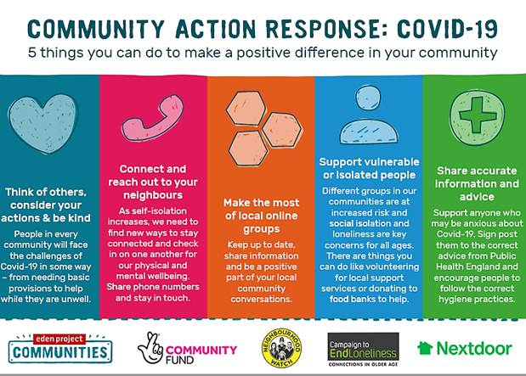

**ABC SENIORS NETWORK – Armagh, Banbridge and Craigavon**

**SIGNPOSTING SERVICES**

Access and Information Service - 028 3756 4300 (Mon - Fri: 8.30am - 5.00pm)

028 9504 9999 (out of hours) access.information@southerntrust.hscni.net

Age NI - First Connect Co-ordinator – Emma Loughlin 07816 230753

To join the Network and sign up to our mailing list phone Faye on 07873 339423

or you can contact our current chairperson David Hammerton by

e-mail: [dhhammerton@hotmail.com](mailto:dhhammerton@hotmail.com)

**Food Parcel and community help**

ABC Network Portadown 028 3839 2777

Trusell Trust Portadown 028 3839 1930

Salvation Army Lurgan 028 3835 2953

Red Cross Portadown 028 3833 3415

**Groceries and prescription collection:**

Aghagallon, aghalee and Ballinderry(Lisburn) Community Association: Fiona 07725355899, Pauline 07936228917, Sarah 07872175962

Clan Eireann North Lurgan: Aisling O’Neill 07876 792298, Ann Marie Henderson 07796951655

NI Car Sales Lurgan will collect and deliver prescriptions for anyone over 65 living in central Lurgan area who have no support. Contact Michael Hoy on 0791728466 or Declan Mc Alinden on 07740268664.

**AGENDA – Age North Down and Ards**

Things are very busy for AGEnda – they have been contacting all their Good Morning Call and Floating Support clients checking where they are at with professional support and family support. They have been providing support and signposting to everyone who requests same.

AGEnda have updated their GMC volunteers

AGEnda have tried not to make promises they cannot keep, things are changing by the minute.

Everyone needs to work together, sick/vulnerable people need to stay at home/hospital.

AGEnda will be checking e mails & 24 answering machine daily at present, please keep in touch. Dorothy W Beattie CEO AGE north down & ards (AGEnda)

24 Hamilton Road Bangor BT20 4LE Telephone 02891271968 Monday – Friday 10am – 2pm (24 hour answering machine)

If very urgent phone – 07725032441 (no answering machine)

E mail agenda@agenorthdownards.co.uk Web www.agenorthdownards.co.uk

Sheila Bailie: Manager/Lead for Peninsula Healthy Living

Tel. 028 427 39021

**Southern Age Well Network (Newry/ Mourne area)**

**Denise McBride/ Kathy Gallagher -** Development Officers



SOUTHERN AGE WELL NETWORK

Ballybot House, 28 COrnmarket, newry co.down bt35 8bg

office: 02830266024 mobile: 07885210488

[denise.nmscc@gmail.com](mailto:denise.nmscc@gmail.com) or [kathy.nmscc@gmail.com](mailto:kathy.nmscc@gmail.com)

<https://www.southernagewellnetwork.org/>

**Down Area**

028 44613434 Good Morning Down in Downpatrick

<https://www.facebook.com/goodmorningdown1/>

**Newtownabbey Senior Citizen’s Forum**

**50 and on the Go -** 02890838848 Website: newtownabbeyseniorcitizensforum.co.uk

**Community Navigator – Stephen Gourley**

Call 07814 196820 Email: communitynavigator.an@ageni.org

The Community Navigator works with the Northern Health and Social Care Trust to link older people to services and activities within their local community.

**For Antrim and Newtownabbey Area check out online information from Citizens’ Advice Antrim and Newtownabbey**

https://www.facebook.com/citizensadviceantrimnewtownabbey/photos/rpp.140286473165347/644095039451152/?type=3&theater

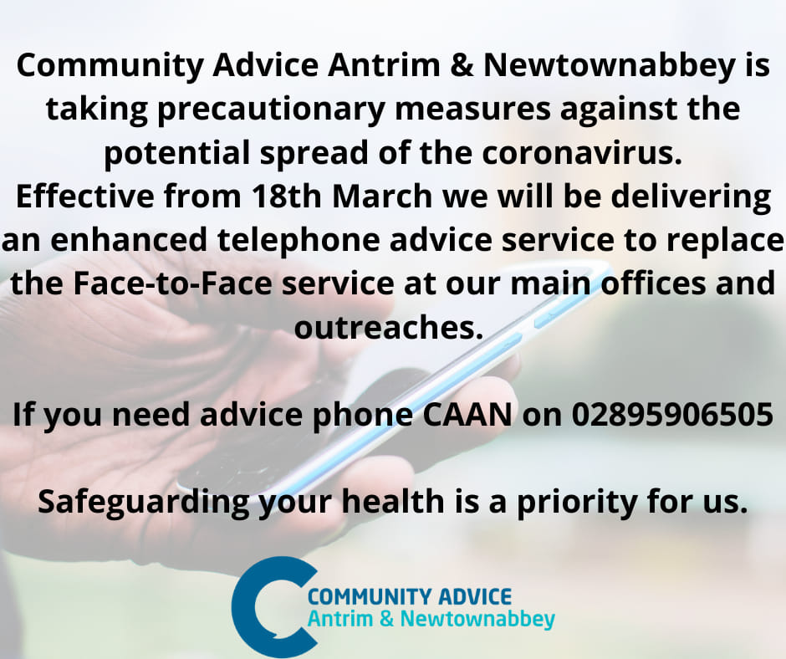

### Learning/ Governance: Learning - Training - At Home Ideas

**What better way to work from home, catch up on Third Sector News, plan some online training or develop an online Facebook support group.**

NICVA have created a new webpage to help support you at this challenging time and to assist with managing the impact of coronavirus. **The new page** has links to Human Resources Guidance, the latest coronavirus funding, and general Public Health Authority advice. It'll be updated regularly, so keep checking NICVA. We'll be sure to keep you posted. <https://www.nicva.org/article/nicvas-advice-on-managing-the-impact-of-coronavirus>

**General guidance - what practical steps can employers take now?**

1.Ensure employee contact numbers and emergency contact details are up to date

2.Remind employees about the importance of hygiene and regular handwashing

3.Provide tissues and sanitiser (where hand washing facilities not immediately available, eg. in meeting rooms)

4.Remind employees about absence reporting procedures and maintain accurate records of reasons for absence whether sickness or leave.

5.Revisit existing policies in the organisation on flexible working options, time off for caring for a dependent and sick leave and pay and look at contracts of employment for any particular clauses which may be relevant

6.Review practices relating to remote working and accessibility.

7.Communicate with staff about the ongoing work of the organisation and any review of working practices

8.Maintain regular contact with employees who are self-isolating whether working from home, or on sickness absence as per your organisational policy

9.Seek employment law guidance from the organisation’s insurer about any employment decisions being considered as a result of COVID-19

10.Stay up to date and in line with PHA employer guidance

**Free membership to Health Alliance & E-zine every 2 weeks to keep up to date with Health events & funding opportunities:** Are you a member of the health alliance yet? Join free today at <http://healthallianceni.com/membership-registration/> to get all the latest health news and opportunities in your area.

You can sign up to receive our fortnightly e-zine to find out about health and well being activities and events. You can also promote your events for free to reach a wider target audience as well as find out about other health and well being activities and events within the Northern Locality area!

The Health Alliance provides an opportunity for communities, voluntary and statutory sectors to: network, share information and best practice, engage in evidence based health improvement, access training and capacity building opportunities and contribute to sharing the health improvement agenda.

**Charity Commission Guidance – changes to annual reporting, meetings, queries and registration**

<https://www.charitycommissionni.org.uk/news/covid-19-coronavirus-information/>

**Social Distancing Guidance:** Guidance on social distancing for everyone in the UK and protecting older people and vulnerable adults - GOV.UK

<https://www.gov.uk/government/publications/covid-19-guidance-on-social-distancing-and-for-vulnerable-people/guidance-on-social-distancing-for-everyone-in-the-uk-and-protecting-older-people-and-vulnerable-adults>

**Online resources for anyone who is isolated at home**: <https://chatterpack.net/blogs/blog/list-of-online-resources-for-anyone-who-is-isolated-at-home>

**Libraries NI:** Libraries across Northern Ireland will be closed until further notice- so this is a great free service everyone can make use of: share on Facebook this link.

<https://www.facebook.com/LibrariesNorthernIreland/photos/a.236634453058050/2724392317615572/?type=3&theater>

### Events and Activities: Regional – Networks – Local

### Regional Activities

### Age Friendly Network NI (AFNNI)

### Age Friendly Network NI meetings are postponed and also the June regional event has been postponed until September 2020.

### ****Ulster Orchestra – Move to the Music Programme****

### **Move to the Music Programme concerts across N.I. 2020 – will be postponed until further notice. For further information contact: shane@ulsterorchestra.com**

### ****Website for individuals offering local help****

### **Please see attached the link to a website I found which has been set-up so that local individuals can offer practical help across Ireland.** <https://randall.ie/help/>

### ****Coronavirus: BBC to delay TV licence fee changes for the over-75s until August****

### **The BBC is to delay TV licence fee changes for the over-75s until August in light of the coronavirus situation.** **BBC chairman Sir David Clementi said “These are ‘exceptional circumstances’ and “now is not the right time.**

### Health Trust Updates

**NHSCT Local Support Service:** View the NHSCT Locality Directories for Information on Support Services Locally -http://www.northerntrust.hscni.net/services/1912.htm

In order to improve our response to queries, support and requests relating to COVID-19 , the Northern Trust have established a single point of contact for all COVID queries for Provider partners. The Partnership HUB will be available 9.00 am to 5.00 pm weekdays and outside of these times, please contact the Community COVID ROTA, contactable via Holywell Hospital 028 9446 5211. We will keep this under review as the situation progresses. Partner HUB contact details: Email:partnerhub@northerntrust.hscni.net Telephone: 028 9442 4707

**SHSCT Local Support Service:** • Information Service 028 3756 4300 (Mon - Fri: 8.30am - 5.00pm), 028 9504 9999 (out of hours)

[access.information@southerntrust.hscni.net](mailto:access.information@southerntrust.hscni.net)

Margaret.devlinhania@southerntrust.hscni.net

**BHSCT Local Support Service:** <http://www.belfasttrust.hscni.net/services/1756.htm>

<http://www.hscboard.hscni.net/new-belfast-service-connecting-people-to-community-support/>

**SEHSCT Local Support Service:** <http://www.setrust.hscni.net/services/1756.htm>

Contact for SET Trust - Primary Care and Older Peoples Services - Telephone 02895988098

* OPTION 1 if YOU ARE currently known to Community Social Care or Mental Health Services for Older People Teams
* OPTION 2 if you are not currently known or wish to make a NEW SOCIAL CARE REFERRAL

**WHSCT Local Support Service:** <https://westerntrust.hscni.net/services/older-peoples-services/>

1st April all non-emergency operations will be postponed.

“Our health and social care system will only be able to cope with Covid-19 if we all rally behind it”. That is the message from Health Minister Robin Swann as major social distancing practices take effect in Northern Ireland. “We are adapting to a new way of life and packages of support and care will change. People’s lives will be affected dramatically and needs will change”

As you all will be aware advice is being updates on a daily basis. Both the PHA and the Department of Health for Northern Ireland’s websites are updated regularly:

Public Health Agency NI - [**https://www.publichealth.hscni.net/news/covid-19-coronavirus**](https://urldefense.proofpoint.com/v2/url?u=https-3A__www.publichealth.hscni.net_news_covid-2D19-2Dcoronavirus&d=DwMFaQ&c=euGZstcaTDllvimEN8b7jXrwqOf-v5A_CdpgnVfiiMM&r=PhdFxadHiA8hpFfTL_gj50PFmNtW3kDh_r0A2sDtChA&m=BTF1S4nuTH5zXO3owyRD59slzUSKkMt0zpdbdl3_6V0&s=LSl8ALiouFGxGTvQLVdIjwSw72LAY_Jip7_SHINwDT4&e=)

Department of Health NI - [**https://www.health-ni.gov.uk/coronavirus**](https://urldefense.proofpoint.com/v2/url?u=https-3A__www.health-2Dni.gov.uk_coronavirus&d=DwMFaQ&c=euGZstcaTDllvimEN8b7jXrwqOf-v5A_CdpgnVfiiMM&r=PhdFxadHiA8hpFfTL_gj50PFmNtW3kDh_r0A2sDtChA&m=BTF1S4nuTH5zXO3owyRD59slzUSKkMt0zpdbdl3_6V0&s=O-Xy0aPD_qdiGAROO66DsblPodaivEsYsGrtqQU3Ppg&e=)



### Local activities and updates

**Community groups are coming together to help most during this critical time for the next 4 months.**

Loneliness is a big issue but the social distancing and social isolating during this corona virus pandemic. This will change communities and how we work over the next few months. We have a resilience community and volunteer sector so let’s all support each other during the next 4 months.

Shopping is another essential need to ensure older people have right nutrition and access to food supplies.

**Shopping – Access to food supplies**

Shopping Centres are prioritising vulnerable and older people for online deliveries.

* 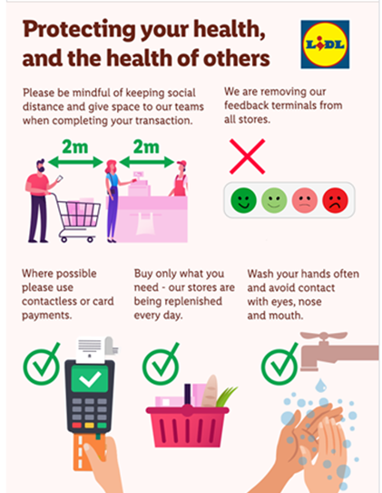Tesco Stores 24 hours stores will start to close overnight 10pm – 6am for restocking.
* Sainsbury’s open first hour for those aged over 70 and only allowing 2-3 items per customer
* ASDA and only allowing 3 items per customer

Being a bit more there for people is what we need to do – keep connected.

Delivery workers being employed for delivery services – home delivery delayed 3-4 weeks.

Popular products such as pasta, tissues and hand sanitisers will have limits.

**UK Governance guidance for providers of residential care, supported living and home care services**

Please find attached a link to UK Governance guidance for providers of residential care, supported living and home care services (published Friday 13 March 2020). This Guidance is also applicable to N Ireland. https://www.gov.uk/government/publications/covid-19-residential-care-supported-living-and-home-care-guidance

We have received questions from Providers about a range of circumstances linked to the COVID-19 situation and have been replying to several of those by email and phone to individual providers.

**URGENT MESSAGE REGARDING CORONAVIRUS SCAMS**

Folks, Police Service of Northern Ireland have got in touch to say they're getting a number of reports about scams involving coronavirus. These include offers to test for the virus and fake emails purporting to give advice from reputable bodies.

These are unprecedented times for us all. It's important we use this as an opportunity to look out, support and protect each other! It should not be used as an opportunity to take advantage of people's fears.

Please share this message with your family, friends, peer groups and local communities . Remember to look out for the most vulnerable in our community during this time, especially those who are older or have underlying health conditions.

Together we can stop the scammers!

**Support for people affected by dementia during Covid 19** 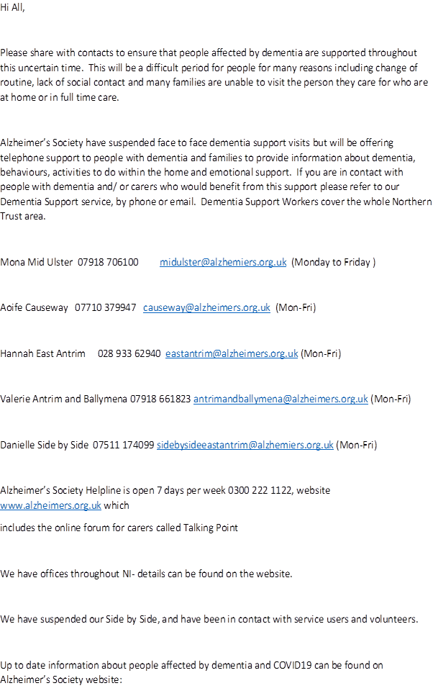

**Dementia Support Workers cover the whole Belfast area.**

Roisin 078 6025 8814 roisin.coulter@alzheimers.org.uk (Tue-Thurs)

Tracy 077 1542 5112 tracy.smyth@alzheimers.org.uk (Mon-Fri)

Catherine 078 8964 8793 catherine.maguire@alzheimers.org.uk (Mon-Fri)

Alzheimer’s Society Helpline is open 7 days per week 0300 222 1122, website www.alzheimers.org.uk which includes the online forum for carers called Talking Point

We have offices throughout NI- details can be found on the website.

We have suspended our Side by Side, Carer Information Support Programme (CrISP) and Singing for the Brain services and have been in contact with service users and volunteers.

Up to date information about people affected by dementia and COVID19 can be found on Alzheimer’s Society website: https://www.alzheimers.org.uk/coronavirus-covid-19

Funding and Sustainability

|  |  |
| --- | --- |
| |  | | --- | |  | |

**Community Foundation have opened a new fund which might be of interest to you, family, colleagues and friends in light of the coronavirus.**

**Check out their website for more details:** [**https://communityfoundationni.org/news/community-foundation-launches-coronavirus-community-fund/**](https://communityfoundationni.org/news/community-foundation-launches-coronavirus-community-fund/)

**Community Foundation launches Coronavirus Community Fund**

Joining the wave of generosity that the coronavirus is provoking from communities across Northern Ireland, the Community Foundation for Northern Ireland has opened a fund for charitable groups supporting older people and dealing with emerging issues from Coronavirus.

Coronavirus presents a significant challenge for communities in Northern Ireland, as well as globally. Current analysis shows that those most likely to be affected by social isolation and serious illness caused by the virus are the elderly, compared to other demographic age groups.

In recognition of the emerging threat particularly to older people; and the great contribution that communities are already offering, the Community Foundation has developed a Coronavirus Community Fund.

The fund will offer between £1,000 and £2,500 of emergency funding to community organisations working with older people **(aged 50 and over)** to help them to deliver support around emerging issues relating to the virus.  We are aiming for a speedy turnaround with successful groups receiving funding within a week.

Andrew McCracken, CEO Community Foundation “We are delighted that we can be responsive and provide further support to communities who are already taking a proactive approach to this emergency. Coronavirus presents a range of challenges for everyone, especially older people, and we want to join the ‘viral kindness’ that we can already see breaking out, supporting communities to make an impact.”

**The fund will open Monday 16th March, 9.00 am. Groups wishing to apply for funding please go to link here: https://communityfoundationni.org/grants/coronavirus-community-fund/**

**If you would like to contribute to this fund and support the people and organisations that are dealing with those most critically affected by the virus, you can make your donation or contact:** [**shealy@communityfoundationni.org**](mailto:shealy@communityfoundationni.org)

### Community Foundation NI All Ages April Grant

A number of NEW funds open for applications:

* Civic Innovation Programme
* Pears Community Spaces Fund
* Comic Relief: Global Health Matters
* Tyrone Three Wind Farms (Gortfinbar, Eshmore and Altamuskin)
* Crighshane and Churchill Community Benefit Funds
* The Pressure Group Fund

Please find below the link for more information: https://communityfoundationni.org/apply

chieving-impact/available-grants/

**CGRF 2020/21 - NOW OPEN for online applications**

Organisations can now register to apply online for a Project Funding grant under the Central Good Relations Fund (CGRF). Registration of your organisation is the first stage in the online application process.

Find out more information about CGRF at: www.executiveoffice-ni.gov.uk/cgrf

Contact the team using this link: ➢ www.executiveoffice-ni.gov.uk/contacts/central-good-relations-funding-programme-team

**Short Deadline for Urgent Small Charity Coronavirus Poverty Relief Applications (UK)**

The £1 million Coronavirus Charity Help Fund has been set up by MoneySavingExpert’s Martin Lewis personal charity fund to help those affected by the coronavirus.

Small registered charities, or local arms of bigger charities can apply now for a grant of between £5,000 and £20,000 for specific coronavirus poverty relief projects in the UK.

Examples could include foodbanks, charities engaged in community aid, financial advice help and more. The hope is to get the money distributed within the next couple of weeks, and thus the focus is on supporting projects that are up and running, or are in the process of being set up.

Please note the funding is only for specific coronavirus projects.

The Coronavirus Charity Help Fund applications click here

The deadline for applications is 11:59 pm on Wednesday 25 March 2020.

**Aviva Community Fund**

Funding is available for fresh ideas looking to secure up to £50,000. Every three months, £250,000 will be shared equally among Aviva’s UK employees to donate to the projects that matter to them most. Each charity can apply for funding of up to a maximum of £50,000 and Aviva employees will decide how the funding is distributed. This funding scheme aims to mix crowdfunding and awards of funds. Through Crowdfunder, causes can also add to any donations they get from the Aviva Community Fund with public donations. <https://acf.crowdfunder.co.uk/start-crowdfunding>

**National Lottery Community Fund**

CEO, Dawn Austwick has issued an updated statement outlining how The National Lottery Community Fund will keep funds flowing to support people, communities and organisations as we navigate a path through Covid-19.

"Our plan is to continue to deliver our services to applicants, grant holders and communities across the UK as normally as we can... At the moment our priority is to keep money flowing to support people, communities and the organisations," she said.

https://www.tnlcommunityfund.org.uk/…/updated-statement-fro…

**Being flexible is a priority**

“We will support you to support your communities – we trust you to know what is best. This means that:

We will be flexible with regards to your current grant: for example,

- accommodating changes to timelines

- accommodating changes to activity to respond to the current climate and critical local needs

We will support you and your teams through this crisis: for example,

- continuing to pay staff salary so that you can support existing staff who need to be off sick, self-isolate or have caring responsibilities

- considering any requests for support if you experience particular financial pressures as a result of the situation

We don’t want you to worry about deadlines and reporting: for example,

- we will be flexible with regards to reporting

- if you record any changes you are making to your project, we can reconcile it all later.

**NATIONAL EMERGENCIES TRUST LAUNCHES APPEAL TO HELP CIVIC SOCIETY SUPPORT THOSE AFFECTED BY THE CORONAVIRUS OUTBREAK**

Duke of Cambridge lends his support to launch the appeal

The National Emergencies Trust has launched an appeal to raise funds to help local charities support those individuals suffering hardship as a result of the coronavirus outbreak.

The appeal has been launched with the support of media, business and governmental organisations, and in partnership with the British Red Cross who will be managing donations. The Trust will then award grants to ensure the funds reach those who need it most across the UK.

Donations can be made at: www.nationalemergenciestrust.org.uk.

Or through the following on-line giving platforms: Just Giving, Go Fund Me, Virgin Money Gives, Good Launch, Muslim Giving.

The National Emergencies Trust will distribute money raised through a number of charitable organisations, for example, local Community Foundations, to ensure it reaches those who need it most.

Those partners will work within parameters agreed with NET to help identify the greatest need and distribute funds with both care and speed wherever possible.

This partnership network has been created by the NET since it was set up last year, in response to recommendations by the Charity Commission following a series of UK emergencies in 2017. The public can be confident that funds will only be granted to trusted organisations who know best the needs of their local communities.

Individuals and charities should not apply directly to the NET for funds. Local charities should contact their local Community Foundation to apply for funding.

"The National Emergencies Trust will help to channel the amazing outpouring of generosity we are seeing from the British public and businesses, and ensure help reaches those most in need."

### Age Sector Networks in N. Ireland

### Get in touch with your age sector network in your local Council area: see the following link for contact details: <https://www.ageuk.org.uk/northern-ireland/get-involved/age-sector/age-sector-networks/>

### Further Age NI Engagement / Opportunities

### Get on the Signpost Express Mailing list: email Michele Young [Michele.young@ageni.org](mailto:Michele.young@ageni.org). If your contact details change, please help us keep your information up to date, by calling 028 9024 5729.

[**Age NI Advice and Advocacy Service**](https://urldefense.proofpoint.com/v2/url?u=http-3A__www.ageni.org_advice&d=DwMFaQ&c=euGZstcaTDllvimEN8b7jXrwqOf-v5A_CdpgnVfiiMM&r=JTRB3-p79ztHeAIA50teEkPQynbMZeCd8Qear-fBAa4&m=NPCSuKbI0nlnULBWl1TShPsg-A_CEJgIS9CPCmUBRXs&s=v-RulwiwYneITBeoIahjT4bpGralzurnOT6NMO0y46o&e=)**:**Free independent and confidential support for older people, their families and carers. **Call Freephone 0808 808 7575**

**Age NI Personal Alarms Contact** 0808 100 4545.

**Age NI Stores: We** always appreciate any stock donations. You can donate to one of Age NI’s five stores in Belfast, Ballymena, Bangor, Carrickfergus, Coleraine and Newtownards.

**Independent Living Products – bathroom aids & adaptations, mobility products and stair/through the floor lifts 028 9024 5729**

**Work for Age NI** - View opportunities <https://www.ageuk.org.uk/northern-ireland/about-us/work-for-us/>;

This is the link to our current vacancy. This is a new First Connect role in the North Belfast area. Also advertised on Jobfinderni and communityni.

**Age at Work project:** Mid Career Reviews aim to support individuals seeking a refresh of their current role, skills and prospects.

**Age NI Volunteering:** Age NI are looking for volunteers. For information or to register, contact Katie on katie.johnson@ageni.org or on 02890 245 729.

[View our website](https://urldefense.proofpoint.com/v2/url?u=http-3A__www.ageni.org&d=DwMFaQ&c=euGZstcaTDllvimEN8b7jXrwqOf-v5A_CdpgnVfiiMM&r=JTRB3-p79ztHeAIA50teEkPQynbMZeCd8Qear-fBAa4&m=NPCSuKbI0nlnULBWl1TShPsg-A_CEJgIS9CPCmUBRXs&s=mx6l0OlFrSvwh0aUR5WXpDK6Gadqtux_2kR1dxdusA8&e=) / [Like our Facebook page](https://urldefense.proofpoint.com/v2/url?u=http-3A__www.facebook.com_agenicharity&d=DwMFaQ&c=euGZstcaTDllvimEN8b7jXrwqOf-v5A_CdpgnVfiiMM&r=JTRB3-p79ztHeAIA50teEkPQynbMZeCd8Qear-fBAa4&m=NPCSuKbI0nlnULBWl1TShPsg-A_CEJgIS9CPCmUBRXs&s=-axhBKLL3rz1tN7OTxZ5BUFyhP5nMMxXekr2cBe2Og8&e=) / [Follow us on Twitter](https://urldefense.proofpoint.com/v2/url?u=http-3A__twitter.com_age-5Fni&d=DwMFaQ&c=euGZstcaTDllvimEN8b7jXrwqOf-v5A_CdpgnVfiiMM&r=JTRB3-p79ztHeAIA50teEkPQynbMZeCd8Qear-fBAa4&m=NPCSuKbI0nlnULBWl1TShPsg-A_CEJgIS9CPCmUBRXs&s=dHK1Z16IVZe43vcNmzXaJestF9mJZ9mzoC44BwP96fA&e=)

### Policy, Consultations and Surveys – Have Your Say as you socially isolate

* **In your experience – what’s your story?** Stories can reflect positive or negative experiences that you or an older person you know has experienced. Sharing your story helps us to identify the issues that matter to older people and build evidence to support our campaigning and lobbying activities. Age NI online questionnaire can capture older people’s experiences of: If you have a story to share, please follow the link below and complete the questionnaire: <https://www.surveymonkey.co.uk/r/inmyexperience>
* **The All Party Group on Ageing and Older People** Michele Smyth from Age NI Policy & Engagement team represents Age NI as Secretariat of the All Party Group. This provides a unique opportunity to develop relationships and engage directly with those responsible for policy making at the highest level. Please give us your stories so we can work with MLAs during this time when we need to liaise with key decision makers and position issues affecting older people such as; emergency care, emergency supplies, loneliness, social care etc. Please email Michele Smyth with any issues: [michele.smyth@ageni.org](mailto:michele.smyth@ageni.org)
* **By filling in Carers UK’ s 2020 State of Caring survey at**: https://www.surveymonkey.co.uk/r/C8VT99Z carers in Northern Ireland can help inform the UK’s most comprehensive study into experiences of looking after a loved one. With plans for social care reform currently being discussed, it has never been more important for unpaid carers to share their experiences.

Please feel free to share this survey round your groups/ contacts.

The survey takes about 20 minutes to complete and will close on the 17th May 2020.

* **Commissioner for Older People** **NI – Meeting with Policy Makers**

The Commissioner for Older People for Northern Ireland states: “In the past week I have met with senior public health officials and the Minister for Communities to discuss what help and support can be put in place as a matter of urgency.

“Discussions are taking place to set up a free telephone helpline so there is a trusted place that over 70s, who do not have the help and support of family members, can access information, help and support.

“I will be continually monitoring the response of the government and as always will raise concerns if I believe the action being taken is not adequately protecting and supporting our older people.

“Do not underestimate the positive effect your actions are having on your older friends, neighbours and relatives.

Read more … <https://www.copni.org/news/2020/march/novel-coronavirus-statement-from-the-commissioner>

**Please share this Signpost with anyone you feel may be interested.**

Age NI is the leading charity for older people in Northern Ireland. We deliver care services, provide advice and advocacy, offer products and services, fundraise and influence our decision-makers to improve later life for us all.

Age NI, 3 Lower Crescent, Belfast BT7 1NR. Company number NI071940. HMRC Charity reference number XTI4600. Registered with the Charity Commission for Northern Ireland NIC104640.

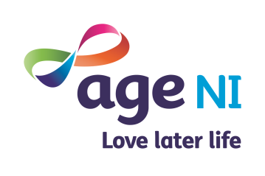

### Please send us information that would benefit the age sector

### Send details to: [elaine.curry@ageni.org](mailto:elaine.curry@ageni.org)