Role (Voluntary) | 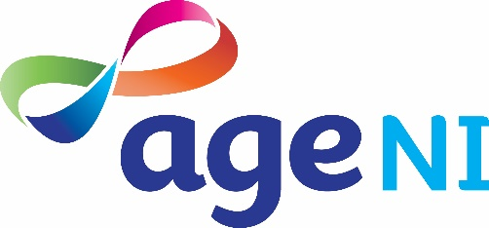  Age NI Consultative Forum Member
Overall purpose of role | To identify the needs and concerns of older people (in relation to poverty, health, equality and other issues) and communicate these to Age NI  To ensure that the voice of ‘lesser heard’ older people is heard through meaningful and effective engagement and included in Age NI policy and practice
Outline of activities | - Influencing - shaping the policies, practices and strategies of Age NI  - Enabling – Age NI to listen and respond to people in later life  - Embracing - equality and diversity of people in later life  - Providing - a channel for older people to engage with Age NI on issues of public policy and practice which affect them  - Representing – be the voice for your peers
Personal qualities and experience | - An interest in older people and knowledge of the issues affecting them  - An ability to listen effectively, communicate well and influence others  - A desire to bring about change on behalf of older people  - Energy, commitment, experience and positivity  - Willingness to give up your time to attend meetings on a quarterly basis  - Willing to attend training, get involved and share your knowledge
Time required | - 1 meeting each quarter  - Occasional sub committee meetings or events  - Occasional training events, briefings or focus groups  - Project activities including peer facilitation. Events and projects can be flexible, however you would be required to be an active participant over and above the quarterly meetings  During Covid 19 meetings have moved online and been held more frequently depending on the issues – this is viewed as a temporary measure.
What can you expect from volunteering at Age NI | - An opportunity to put older people at the heart of issues that matter to them  - First hand input into the strategic direction of Age NI  - Involvement in a range of peer led projects where  you will have the opportunity to engage directly with older people in a range of settings  - An opportunity to be a member of a team of dedicated volunteers  - Support and training on a range of new skills including communication and media skills, peer facilitation skills and techniques, reporting back  - The role is voluntary, although Age NI will reimburse out of pocket expenses incurred as a result of volunteering with us
Location | - We are seeking Consultative Forum members from across Northern Ireland  - The Consultative Forum meets in central Belfast during normal times, meetings have moved to Zoom online during the time of Covid.
To apply, or for any further information about the role contact: | Seamus Donnelly  Engagement Manager, Age NI:  02890 8926179 or 02890 245729  e-mail: seamus.donnelly@ageni.org

