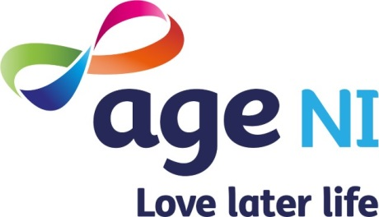
Role Description

Our Vision

A world where everyone can love later life.
Our Mission

To help people enjoy a better later life

Job Title

Information Support Officer

Our Values
- You matter
- We care
- Together we make a difference

Role Description

Job Title: | Information Support Officer
Department | Information and Advice
Location: | Lower Crescent Office, Belfast
Type of role: | Full-time
Contractual Status: | 3 years fixed term contract
Hours: | 35 hours per week
Line Manager | Head of Advice & Advocacy
Job Purpose: | Responsible for providing an exemplary ‘first port of call’ service in a multi-channel environment, delivering information and support, signposting to internal and external supports available to older people
Main Responsibilities/ Deliverables: | - Provide a professional service, maintaining standards for call answering with particular emphasis on confidentiality, empathy, patience, understanding and impartiality  - Assess and triage customer’s enquiry and identify the most appropriate services and options for their situation(s)  - Establish customer contact preferences and comply with data protection processes  - Manage interactions in line with agreed processes: capture and record information, provide customers with signposts to information and resources, escalate to other teams, and refer enquirers to other services as required  - Respond to interactions across different channels, including telephone, e-mail, post, and webchat.  - Provide accurate and impartial information in response to non-complex enquiries  - Utilise tools and resources to answer enquiries and to convey this in a concise and understandable format  - Manage customer expectations and adapt to current campaigns and / or media activity  - Operate and utilise computer system effectively for information retrieval and to ensure data is stored accurately  - Handle enquiries in line with regulatory and quality standards, including Age UK Information & Advice Quality Programme  - Recognise, assess and escalate safeguarding incidents  - Attend training and access resources to ensure an understanding of Information & Advice subject matter areas  - Maintain up-to-date knowledge and understanding of Age NI’s Information & Advice literature, products and services, signposts, policies, and processes.  - Complete all activities in line with agreed policies and procedures  - Meet or exceed targets in line with business plan  - Undertake other administrative support duties and attend meetings as required.
Experience: | - Previous experience in call handling, helpline work or Customer Service  - Experience of using CRM systems to process customer data
Knowledge: | - Demonstrate a sound understanding of customer service and quality assurance
Skills: | - Good understanding of Word / Excel / Outlook  - Accurate data entry skills  - Excellent listening, verbal, oral and written communication skills  - Strong organisation and planning skills  - Numeracy skills  - Information management skills  - Ability to take a creative approach when responding to queries or situations  - Confident, professional, outgoing telephone manner  - A positive team player
Qualifications: | - Customer Service Qualification (Desirable)  - ECDL (European Computer Driving Licence) or equivalent qualification (Desirable)
Additional Circumstances: | Dependable and flexible approach  Post-holder will be subject to an enhanced Access NI disclosure
Notes:
- This role description is not intended to be exhaustive in every respect, but rather to clearly define the fundamental purpose, responsibilities and dimensions for the role. Therefore, this role description does not describe any individual role holder.
- In addition to the contents of this role description, employees are expected to undertake any and all other reasonable and related tasks allocated by line management

