September 2018
Transport (Scotland) Bill
Scottish Parliament: Rural Economy & Connectivity Committee

Introduction
Age Scotland welcomes the introduction of the Transport (Scotland) Bill, which was a key commitment in the SNP 2016 Scottish Parliament manifesto.
Our positions on transport are based on evidence and on what older people have told us directly. Throughout 2018 Age Scotland has been engaging extensively with hundreds of older people on the topic of transport. We have hosted 14 workshops to date on the National Transport Strategy Review – with a further 10 planned for the autumn – which have already allowed more than 300 older people the opportunity to explain what they need from Scotland’s transport system. These workshops have taken place in every corner of Scotland – north, south, urban, rural and island communities. Views and data gathered at the workshops and from our workshop questionnaire are shaping our charity’s own policy priorities as well as directly influencing the new National Transport Strategy (NTS2).
With the proportion of people aged 75 and over set to double in many areas of Scotland over the next two decades, and the number of people living with dementia set to rise dramatically, it is essential that our transport system meets the needs of older people if it is to be fit for purpose. We believe the Transport (Scotland) Bill as introduced, together with NTS2, is an important part of the jigsaw.
We shall focus our comments in this submission on the Parts of the bill which, older people tell us, are of specific interest.
General overview of the bill
Age Scotland broadly welcomes the provisions within the Bill as they relate to older people. However, we consider it a missed opportunity that the Bill makes no provision for the extension of the National Concessionary Travel Scheme to cover journeys made on demand-led community transport. The current system disenfranchises many older people, particularly those in rural areas who cannot access timetabled public bus services for a multitude of reasons including, for example, in places where timetables services do not exist, or are so infrequent as not to be useful, or the bus vehicles themselves are not sufficiently accessible. For these reasons, many people cannot make use of their entitlement to free bus travel in Scotland.
Age Scotland considers it essential that Scotland’s transport infrastructure meets the needs of an aging population where the number of people living with dementia and other age-related conditions affecting sight, hearing and mobility is projected to rise.
Part 1 – Low Emission Zones
Age Scotland believes that older people should be empowered to enjoy a fulfilling, active and healthy later life as far as possible. This means that any barriers to physical activity – such as socialising, shopping, or exercising – should be minimised as far as possible. There is a proven link between high concentrations of vehicle emissions and the prevalence of dementia. The promotion of cleaner air in low emission zones would in theory make urban areas healthier places to live. This has two potential positive effects. Firstly, cleaner air means better health outcomes for people who already breathe that air. Secondly, positive news in the media that air quality is improving would encourage older people to spend more time outdoors. We do accept that it could be difficult to measure such a behaviour change in the short term, but the health effects of a markedly better air quality would no doubt be demonstrable within the longer term and the social benefit of getting out and about more is obvious.
Part 2 – Bus Services
Background
Well-run bus services are essential for the wellbeing of older people in Scotland. Aside from the car, public bus services are by far the most commonly used form of public transport amongst older people, due in no small way to the existence of free bus travel for people aged over 60.
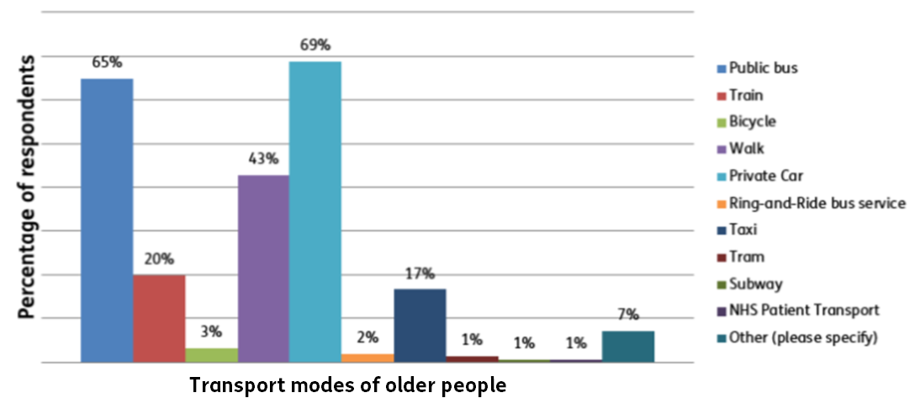
Figure 1 Age Scotland transport questionnaire, 2018
Age Scotland’s own research shows that older people use bus services for a wide range of purposes, and that the effect of good bus links is worth a lot more than simply getting people from A to B. Many older people have told us they take the bus to attend medical appointments, to visit friends and family, and for socialising – all things important to health and wellbeing. However, many also use buses to get to volunteer work, to fulfil childminding duties and, most commonly of all, for shopping. It is clear therefore that bus services are not just a essential part of the health and wellbeing of older people in that they help to reduce loneliness and isolation, but that they also allow older people to make an enormous contribution to the economy as identified in the University of Leeds research.
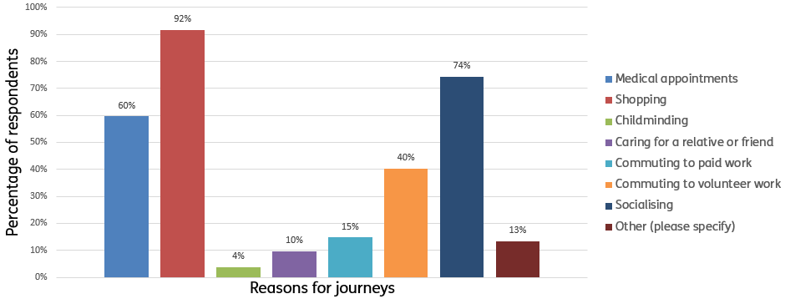
Figure 2 Age Scotland transport questionnaire, 2018
Scotland is facing major demographic change in the coming decades. Population projections illustrate that the proportion of the population aged 75 and over is set to double in many areas of the country in the next two decades. It is therefore essential that our public transport infrastructure, and our bus services in particular, meet the needs of our older population. If public transport does not meet the needs of older people, it will simply not be fit for purpose. Age Scotland’s extensive work with Transport Scotland on the revised National Transport Strategy (NTS2) has that principle at its core.
Comment on provisions within Part 2
Age Scotland welcomes the innovative measures set out in the bill which seek to improve bus services.
We do not take a position on who should design or run bus services. Rather we believe that private operators, local authorities, the Traffic Commissioner and all other bodies involved in the provision and oversight of bus services must ensure that the needs of older people are met.
Age Scotland recognises that bus service needs and operating costs vary enormously due to Scotland’s geographic spread – the results of our transport questionnaire illustrate this. We therefore support the principle behind provisions in the bill to grant local transport authorities greater flexibility to engage in partnership working with bus operators. The provisions allowing local transport authorities to franchise, or indeed to run their own services, are welcome. We would not take a position on which model of provision any particular route should adopt, but we believe that flexibility is positive in that it allows more localised decision-making. This is particularly important in rural and island communities where bus services are often lifeline links and where the community transport sector is undervalued, underfunded and patchy.
On community transport, Age Scotland does consider it a missed opportunity that the bill as introduced makes no provision for extending the National Concessionary Travel (NCT) scheme to all demand-led community transport. Many older people are simply disenfranchised from the NCT, particularly in rural areas, because there are no public bus routes or, where there are, only very limited timetables, or indeed inaccessible vehicles. The latter problem may also apply in urban settings.
Part 3 – Smart Ticketing
Age Scotland cautiously welcomes provisions within the bill to allow for greater use of smart-ticketing schemes by local transport authorities, with a national technological standard in place. However, any moves towards smart taking must be age-inclusive. This has less of an impact than it would if the NCT scheme did not exist, where older people are able to simply present their card when boarding a bus to allow for free travel. However, any moves away from a physical card and towards more digital formats of ticketing would be a serious concern. We know that older people in Scotland are less likely than younger generations to use a smartphone, which poses a problem with digital ticketing. Indeed, 67% of over 65s in Scotland do not use the internet at all.
Age Scotland advocates for the interests of all people aged over 50. With 2 in 3 Scots aged 50-64 in work, and not covered by the NCT scheme, it is important than transport payment options evolve with consumer habits. We therefore believe that bus operators across Scotland should be supported to introduce the option of contactless payment onboard using a debit or credit card or mobile device.
Age Scotland welcomes the proposed establishment of a National Smart Ticketing Advisory Board and believes that the interests and needs of older people should be a priority consideration for such a body.
Part 4 – Responsible Parking
Part 4 of the bill is a crucial and very welcome step in making Scotland’s streets more accessible and age-friendly. Pavement parking alone has long been a scourge on the lives of many older people, particularly those who have visual impairments, hearing loss, or limited mobility. Numerous calls to the Age Scotland Helpline have highlighted this problem.
The proposed prohibition of double parking and parking on pavements is welcome, but further clarity is needed on how this would be enforced. Many examples of problem parking exist around Scotland where both Police Scotland and the local authority do not have the resources to issue fines or indeed to function as a visible deterrent to such behaviours in the first instance. It is essential that the effect of these provisions is applicable uniformly across Scotland, whether antisocial parking is decriminalised or not.
Part 5 – Road works
Background
Where road works take place in an urban area, or indeed any built-up area where pedestrians might walk, it is essential that pedestrians can make their way around road work sites safely. This means that diversions must be accessible, clearly signposted and dementia-friendly. If road works effect a bus stop, or a transport hub, it is important that passengers can quickly and efficiently find out, in the clearest terms, what they should do to get around the obstacle. It is also important that any scheduled roadworks on pavements or footpaths are advertised in advance so that people with limited mobility, or people living with dementia, or their carers, are able to formulate alternative travel plans in advance. It would also be good to advertise how long road works are scheduled for so older people can assess if they need to make longer term arrangements. When these steps are not taken, Age Scotland hears from older people and concerned relatives via our Helpline and via our Community Development team.
Comment on provisions within Part 5
Age Scotland welcomes the provisions to enhance the powers of the Scottish Road Works Commissioner and indeed to improve the regulation of road works more generally. Any move to improve reinstatement quality plans must be accompanied by a meaningful process of enforcement so that defects can be put right as quickly as possible to avoid falls or other accidents.

Want to find out more?
As Scotland’s national charity supporting people over the age of 50, Age Scotland works to improve older people’s lives and promote their rights and interests. We aim to help people love later life, whatever their circumstances. We want Scotland to be the best place in the world to grow older.
Our Policy, Communications and Campaigns team research, analyse and comment on a wide range of public policy issues affecting older people in Scotland.
Our work is guided by the views and needs of older people themselves.
Further information
Contact the Age Scotland Policy, Communications and Campaigns team:
policycomms@agescotland.org.uk
0333 323 2400
Twitter @agescotland
Facebook /agescotland
Linkedin Age-Scotland
www.agescotland.org.uk

British Medical Journal online – study accessible at https://bmjopen.bmj.com/content/bmjopen/8/9/e022404.full.pdf
BBC News - https://www.bbc.co.uk/news/uk-scotland-38623508 Number of pollution zones in Scotland rises to 38, 21 Jan 2017
Buses and the Economy II – University of Leeds, 2014. https://greenerjourneys.com/publication/buses-economy-

