Parliamentary Briefing
Members Debate (Brian Whittle): Transport Infrastructure in South West Scotland
8 January 2019

Introduction
Age Scotland welcomes the opportunity to brief MSPs in advance of the Members Debate on Transport Infrastructure in South West Scotland.
With the proportion of people aged 75 and over set to double in many areas of Scotland, including the South West, over the next two decades, and the number of people living with dementia set to rise dramatically (at least a 50% increase over next 20 years), it is essential that our transport system meets the needs of older people if it is to be fit for purpose.
Our Recommendations
Age Scotland welcomes the opportunity which this debate provides to highlight the issues in relation to transport infrastructure in South West Scotland as they relate to older people. We recognise the valuable contribution which good transport infrastructure can play in improving the quality of life of older people. In particular we would like to highlight:
- Age Scotland believes that the National Concessionary Travel Scheme (NCTS) should be extended to include demand-led Community Transport.
- The Scottish Government to ensure that the refreshed National Transport Strategy (NTS2) brings forward specific proposals to overcome the challenges of providing accessible and affordable transport services in rural areas.
- Age Scotland is calling on the Scottish Government to commit to sustainable long term investment in transport infrastructure and services for the benefit of older people in South West Scotland.
Our positions on transport are based on evidence and on what older people have told us directly. Throughout 2018 Age Scotland engaged extensively with hundreds of older people on the topic of transport. We have hosted over 20 workshops with older people to date on the National Transport Strategy Review in conjunction with Transport Scotland, which has allowed them the opportunity to explain what they need from Scotland’s transport system now and in the future. These workshops have taken place in every corner of Scotland – including in communities in South West Scotland. Views and data gathered at the workshops and from our follow up questionnaire are shaping our charity’s own policy priorities as well as directly influencing the new National Transport Strategy (NTS2).
We have welcomed the Scottish Government and Transport Scotland’s positive approach to engaging with older people in this way and the opportunity to listen to their needs.
Bus Services
Well-run bus services are essential for the wellbeing of older people in Scotland. Aside from the car, public bus services are by far the most commonly used form of public transport amongst older people, due in no small way to the existence of free bus travel for people aged over 60.
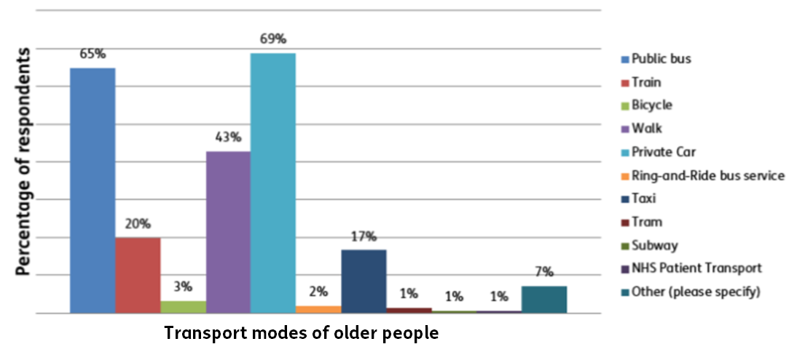
Figure 1 Age Scotland transport questionnaire, 2018
Age Scotland’s own research shows that older people use bus services for a wide range of purposes, and that the effect of good bus links is worth a lot more than simply getting people from A to B. Many older people have told us they take the bus to attend medical appointments, to visit friends and family, and for socialising – all things important to health and wellbeing.
However, many also use buses to get to volunteer work, to fulfil childminding duties and, most commonly of all, for shopping. It is clear therefore that bus services are not just an essential part of the health and wellbeing of older people in that they help to reduce loneliness and isolation, but that they also allow older people to make an enormous contribution to the economy as identified in the University of Leeds research.
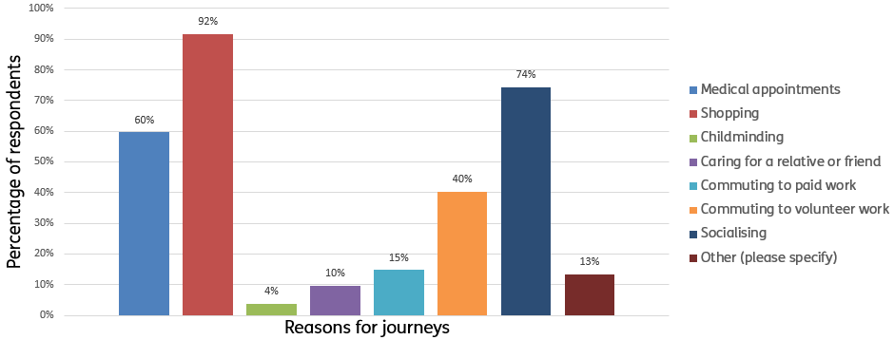
- Figure 2 Age Scotland transport questionnaire, 2018
Scotland is facing major demographic change in the coming decades. Population projections illustrate that the proportion of the population aged 75 and over is set to double in many areas of the country in the next two decades. It is therefore essential that our public transport infrastructure, and our bus services in particular, meet the needs of our older population. If public transport does not meet the needs of older people, it will simply not be fit for purpose. Age Scotland’s extensive work with Transport Scotland on the revised National Transport Strategy (NTS2) has that principle at its core.
Age Scotland highlights the importance of bus services for older people. This is particularly important in rural communities where bus services are often lifeline links and where the community transport sector is undervalued, underfunded and patchy.
National Concessionary Travel Scheme
Age Scotland warmly welcomes the news that eligibility for the National Concessionary Travel Scheme (NCTS) will remain at 60 but calls for the extension of the NCTS to cover journeys made on demand-led community transport.
Since the introduction of the NCTS it:
- has proven to be extremely popular with older people;
- helps older people live active, healthy and engaging lives;
- generates £4 into the economy for every £1 invested;
- contributes to the viability and sustainability of bus routes in rural areas; and
- has a wider positive social impact – allowing unpaid carers and volunteers to travel,
thereby allowing older people to make a valuable contribution within their community and to help others.
However the current system can disenfranchise many older people, particularly those in rural areas who cannot access timetabled public bus services for a multitude of reasons including, for example, in places where timetabled services do not exist, or are so infrequent as not to be useful, or the bus vehicles themselves are not sufficiently accessible. For these reasons, many people cannot make use of their entitlement to free bus travel in Scotland.
Age Scotland believes that the NCTS should be extended to include demand-led Community Transport.
We consider it essential that Scotland’s transport infrastructure meets the needs of an aging population where the number of people living with dementia and other age-related conditions affecting sight, hearing and mobility is projected to rise. After all, if our infrastructure is age -friendly, it is fit for all generations and future proofed.
Challenges of providing good transport services in rural areas
There are a number of challenges to providing good quality, accessible and affordable public transport in rural areas in the South West of Scotland. Age Scotland’s extensive consultation with older people and older people’s groups reveals the following:
- Inaccessible bus vehicles
- Infrequent bus services with limited scheduled services
- Poor access to toilets in stations, transport hubs and on board vehicles
- Lack of evening bus services
- Poor integration across different modes of transport
- Lack of formal bus stops
Age Scotland calls on the Scottish Government to ensure that the refreshed National Transport Strategy (NTS2) brings forward specific proposals to overcome the challenges of providing accessible and affordable transport services in rural areas.
Tackling loneliness and isolation
Age Scotland warmly welcomes the Scottish Government’s publication of “A Connected Scotland”, the nation’s first ever strategy for tackling social isolation and loneliness. The strategy specifically highlights the role which transport can play. It states:

“Accessible transport is vital to people being able to meet face-to-face and stay socially active, particularly for those in rural areas or later in life.”

Age Scotland agrees that access to reliable, affordable transport can play a major role in helping to tackle loneliness and isolation.
- half of Scottish adults over 75 live alone;
- 100,000 older people in Scotland feel lonely most or all of the time;
- Loneliness kills – it raises the risk of death by 10% and is as bad as 15 cigarettes a day.
Having good transport infrastructure and services helps older people get active and be engaged in their local communities.
Older people often have carer roles and use public transport to fulfil their duties.
Age Scotland is calling on the Scottish Government to commit to sustainable long term investment in transport infrastructure and services for the benefit of older people in South West Scotland.
About Age Scotland
Age Scotland is Scotland’s leading charity advocating on behalf of older people. Our vision is a Scotland where everyone can love later life. Our mission is to inspire, involve and empower older people in Scotland, and influence others, so that people in Scotland can enjoy better later lives.
Age Scotland’s Strategic Aims are to promote positive views of ageing and later life; help older people to be as well as they can be; and to tackle loneliness and isolation.
For more information:
Contact the Age Scotland Policy and Communication team on policycomms@agescotland.org.uk or 0333 323 2400
Adam Stachura – Head of Policy and Communications - adam.stachura@agescotland.org.uk

Buses and the Economy II – University of Leeds, 2014. https://greenerjourneys.com/publication/buses-economy-
A Connected Scotland Our strategy for tackling social isolation and loneliness and building stronger social connections, Scottish Government, December 2018, p. 65.

