MEMORY CONNECTIONS
- Welcome.
- Let’s get vocal.
- Orientation.

- What’s topical?


News
Bristol News

5.

- German Quiz Odd Word Out



Points of view.
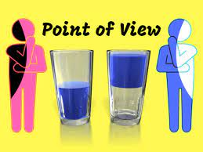

- Summary & Thank you.
- Theme song.

- Next time.

