  - October 2024
Volunteer expenses
Policy and Procedure

No one should be out of pocket as a direct result of volunteering with Age UK. We will reimburse volunteer expenses including travel, subsistence, and other agreed expenses.
Given the variety of volunteering roles at Age UK, we recognise that not all volunteers will need to claim expenses regularly in order to carry out activities relevant to their role. However, this policy applies to every volunteer who may at any time incur in out-of-pocket expenses to be able to carry out a volunteering activity agreed in advance with and approved by Age UK.
The following terms and conditions apply:

Travel expenses
Age UK will reimburse reasonable travel expenses to and from the place of volunteering, unless the role is based remotely in which case volunteers are not expected to travel. This must be the actual cost of expenses incurred or a reimbursement based on the mileage undertaken.
As a charity, we can only reimburse up to and no more than the equivalent to 1 day London Pay as you go cap (zones 1-9), or the equivalent modest form of standard public transport travel relevant in each region. When a volunteer needs to travel by train, they must ensure their ticket is a standard or a cheap day single or return, but not a first-class ticket. We encourage volunteers to travel during off peak hours whenever possible.
Volunteering leaders can, at their discretion, approve longer distance travel for volunteers in their team, ensuring there is adequate budget to cover the expenses incurred.
If a volunteer must travel in a private vehicle, we can reimburse their mileage in line with the HMRC mileage rate for each tax year.
Retail volunteers who offer more than four hours per day can claim mileage up to the value of £10 if it has been agreed in advance with their Area Sales Manager (ASM).

Current Rates of Allowance
Transport method | Usage in tax year rate | Rate
Own cars | First 10,000 miles | 0.45p
Own cars | More than 10,000 miles | 0.25p
Own motorcycles | All mileage 0.24p | All mileage 0.24p
Bicycle | All mileage 0.20p | All mileage 0.20p
Volunteers are required to keep track of volunteering mileage incurred in the tax year (6 April to 5 April) to ensure the correct rates are used. Mileage figures can be requested without notice by Age UK Risk & Compliance, Auditors (Internal and External and HMRC).
When claiming motor mileage, volunteers are confirming that the following obligations have been met:
- Possession of a valid UK driving licence.
- Valid insurance policy endorsed for volunteering use.
- The vehicle has a valid MOT certificate (if over 3 years old).
- The vehicle is adequately taxed.
- The vehicle is properly maintained.
- The mileage figure being submitted is true and accurate.
For volunteers with additional needs or in exceptional circumstances, other travel expenses can be agreed in advance at the discretion of their volunteering leader.

Subsistence
This is the actual cost of meals taken whilst volunteering.
Volunteers can claim the exact expense of up to and no more than £5.00 for subsistence (ie lunch, breakfast, or dinner) as long as they have volunteered for at least 4 hours on a given day.
The expense receipt must show itemised items have been purchased to be consumed on the volunteering date and during the volunteering shift break (ie a meal deal, hot soup and a piece of bread, a salad, and a pack of crisps, etc). Items intended to be consumed long after or before the volunteering shift cannot be reimbursed (ie ingredients for a later dinner or items consumed before the volunteering shift starts).
Volunteering Leaders can use their discretion to approve in advance additional expenses volunteers may incur due to the particular characteristics of a volunteering activity. For instance, authorising additional incurred expenses over the cap limit for travel and/or subsistence when it is unreasonable to expect these expenses to be within the limit, as long as there are sufficient funds in their budget to cover these.

Other approved expenses
- The actual cost of any specialist clothing needed to carry out the volunteering tasks if this has been pre-approved by the appropriate manager.
- The actual expenditure incurred in the purchase of materials or services required to carry out the volunteering tasks if this has been pre-approved by the appropriate manager. Whenever possible, Age UK will lend aids to volunteers to enable them to carry out their volunteering activity (ie a mouse, headphones, and a keyboard). If this is not a suitable option for the volunteer (ie the volunteer requires a left- hand, ergonomic, wireless mouse compatible with their computer) any additional expenses may be reimbursed at the discretion of the Volunteering Leader. This does not apply for roles that require volunteers to already have access to basic equipment (ie a phone line, a mobile phone or a tablet, access to the internet) in order to volunteer.
- Retail Volunteers at Age UK (National Shops) can claim car parking expenses if they have been on shift for more than 4 hours per day. The charges must be reasonable and agreed by their Shop Manager.
- It is at the discretion of Volunteering Leaders to approve the reimbursement of other reasonable expenses volunteers may incur in order to be able to carry out their volunteering activities.

Overnight accommodation and late dinner
Although Volunteering Leaders are encouraged to recruit volunteers locally, Age UK recognises that, occasionally, specific roles require volunteers to travel and stay overnight away from their regular place of volunteering. For instance, Engagement Consultative Network Volunteers needing to travel to attend a face-to-face meeting, or fundraising volunteers who must assist with the setting up, running and clearing up of an event. In these exceptional circumstances, volunteers staying overnight can claim a late evening meal/dinner (up to the value of £25) and breakfast (up to the value of £5) as long as these expenses have been approved in advance by their Volunteering Leader.
Like staff in the same circumstances, volunteers who must stay overnight away from their regular place of volunteering and are travelling in representation of Age UK, can claim back one glass of an alcoholic drink (guidance: up to 3 units of alcohol) provided it is with food as part of a subsistence claim. Volunteers are expected to conduct themselves in an appropriate manner at all times and ensure their consumption of alcohol does not bring Age UK into disrepute or affect their ability to carry out their role.
These expenses must be supported by a detailed itemised receipt. The limits mentioned above are for the maximum expenditure and are not a cash allowance.
When overnight accommodation is unavoidable, the Volunteering Leader must seek approval from their manager and then book it on behalf of volunteers via Click Travel or request support from the volunteering team (volunteer@ageuk.org.uk) to book the travel and accommodation for volunteers.

Subsistence during a lengthy period of absence (over 10 hours)
In line with the Age UK staff expenses policy, volunteers can claim the following expenses during agreed periods of absence from their regular place of volunteering when travelling in representation of Age UK as follow:
Period of absence | Limit
One meal rate:  The amount claimed must be reasonable and should not normally exceed £5. This may include breakfast if the volunteer travels away from their normal place of volunteering and leaves before their agreed start time. It is recognised that hotel breakfasts may cost more and therefore the claim may sometimes exceed this figure. | £5
Two meals rate:  If the volunteer is away from home/usual place of volunteering for at least 10 hours they can buy two meals up to this value. | £10
Late evening meal:  If the volunteer is required to carry out an activity on behalf of Age UK later than 8pm in addition of their agreed hours or buys dinner during an overnight trip on behalf of Age UK. | £25
Incidental expenses UK. | £5
Gratuities will not be reimbursed | N/A

Proof of expenses
Volunteer reimbursement claims must be accompanied by a genuine proof of expense. Age UK accepts the itemised original, scanned copies, photographs, or downloads (showing the date of purchase and the amount incurred) of the following proofs of expenses:
- Receipts of purchase for subsistence and other pre-approved expenses.
- Oyster, railway, or other official travelling card printout highlighting the journeys made to and from the place of volunteering.
- Bus or train ticket.
- Credit/debit card statement for travel expenses (highlighting the journeys made to and from the place of volunteering).
Volunteers must complete the appropriate volunteering expenses claim form to be reimbursed.

If claiming mileage allowance, volunteers must also confirm:
- the distance travelled (number of miles driven for each trip to and from the place of volunteering)
- the place where their journey commenced and the location of each volunteering trip's destination
- the date and time of each journey.
Retail volunteers should also provide a receipt for fuel dated within a week of the claim date.

Frequency
Volunteers are encouraged to claim expenses as often as possible and or needed.
Age UK will reimburse expenses claims submitted no later than three months from the date incurred. Claims submitted after three months will not be reimbursed.

Trustees and committee members
Although Trustees and committee members are considered volunteers, due to the nature of their role, and level of responsibility, this procedure does not apply to them. Instead, the Age UK Group- Travel and Subsistence Policy covers them.

Appendix 1


Volunteer expenses template
Volunteer and intern expenses form. All receipts and supporting documents must be attached to this claim form.
PO number:
Name of volunteer: |  | Contact number:
Date: | Description of expense:  Eg ‘Phone calls; meals, travel - list details of journey (to / from, including method of travel) |  | Total:
Total amount claimed:
Signed by volunteer: |  | Date:
Volunteer Bank sort code:
Volunteer Bank account number:
Manager name:
Managers signature: |  | Date:
Cost centre:
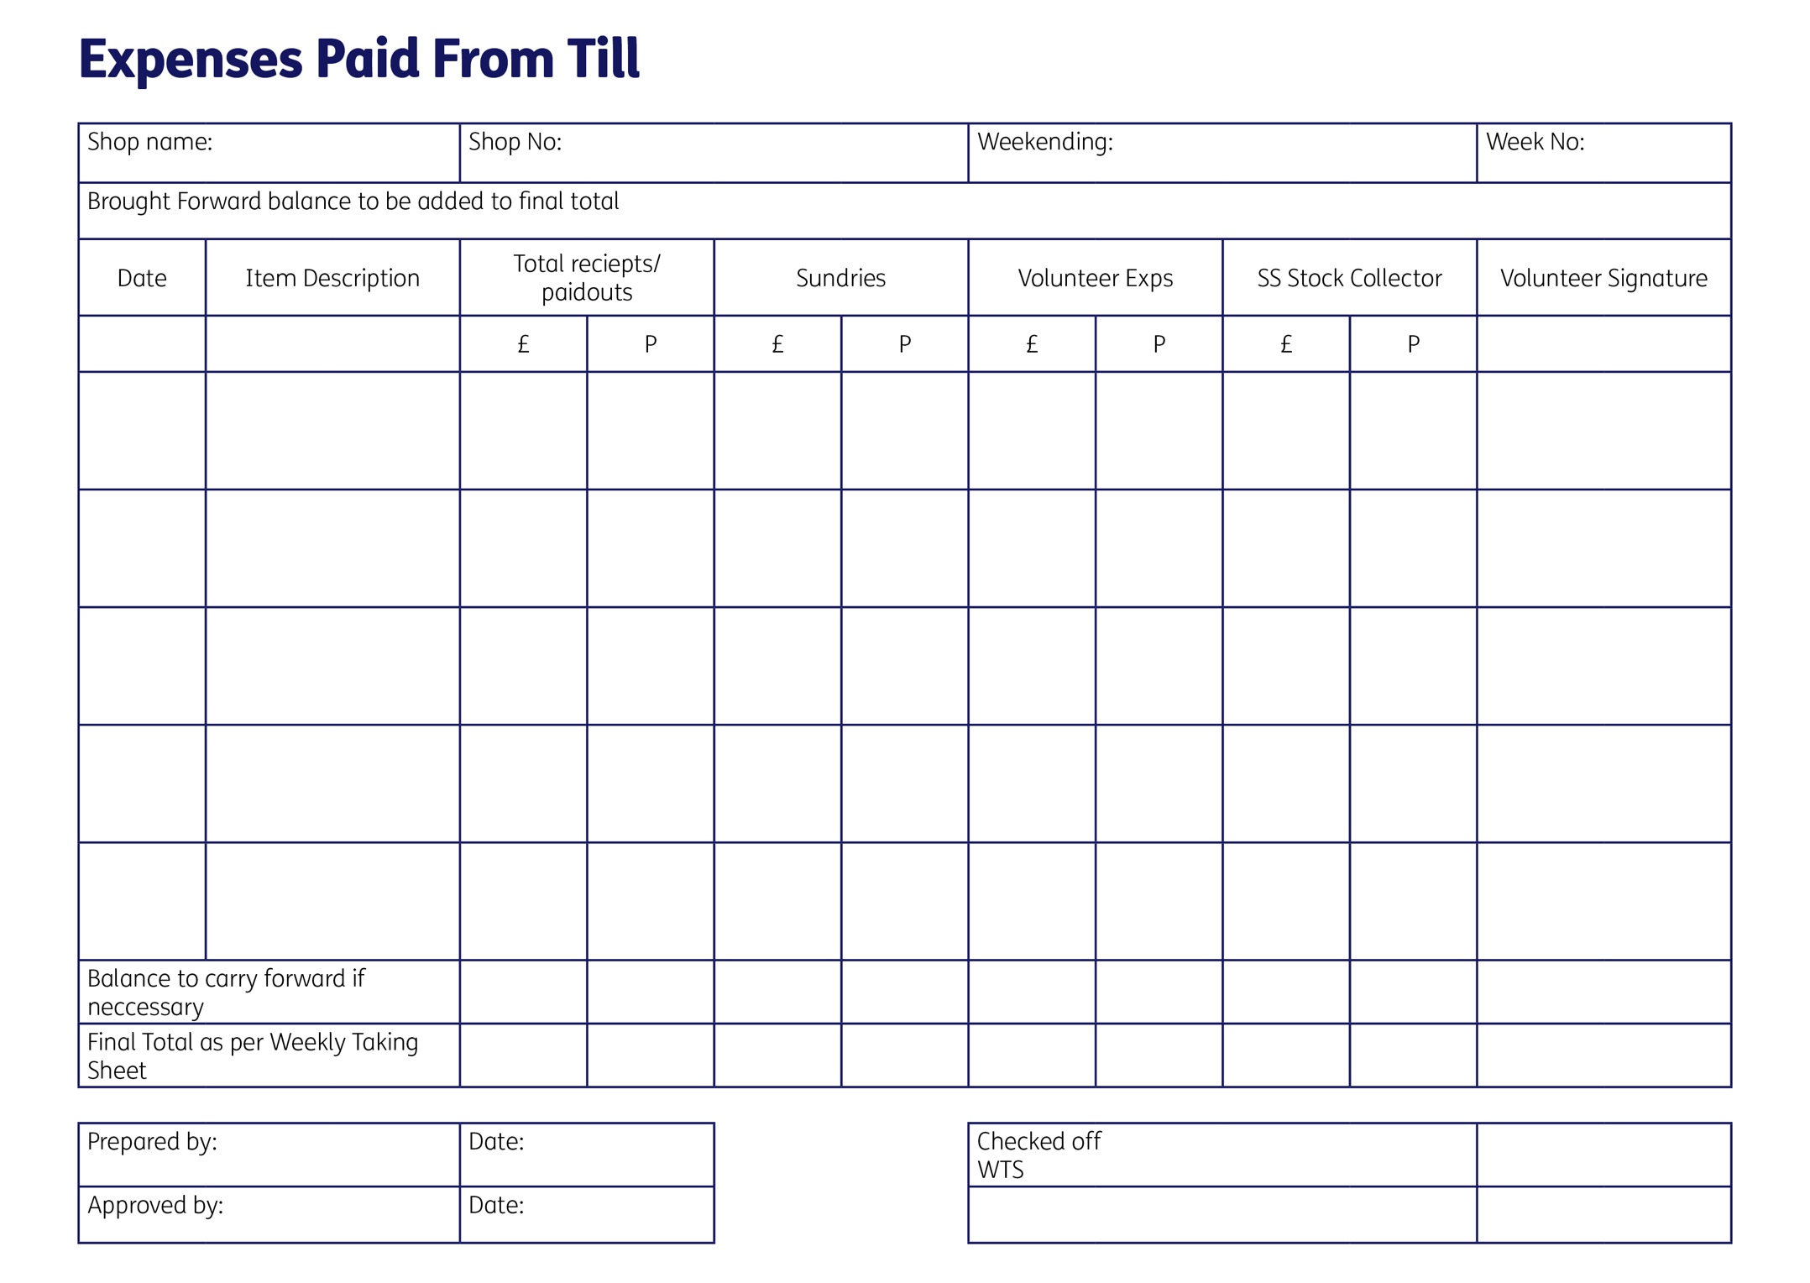

https://tfl.gov.uk/fares/find-fares/tube-and-rail-fares/caps-and-travelcard-prices?intcmp=54720
https://www.gov.uk/government/publications/rates-and-allowances-travel-mileage-and-fuel-allowances/travel-mileage-and-fuel-rates-and-allowances

